UNITED STATES
SECURITIES AND EXCHANGE COMMISSION
WASHINGTON, D.C. 20549

FORM 8-K

CURRENT REPORT
Pursuant to Section 13 or 15(d) of the Securities Exchange Act of 1934
Date of Report (Date of earliest event reported): August 13, 2026

Parabilis Medicines, Inc.
(Exact name of Registrant as Specified in Its Charter)

Delaware |  |  | 001-43331 | 47-4505725
(State or Other Jurisdiction  of Incorporation) |  |  | (Commission File Number) | (IRS Employer  Identification No.)
30 Acorn Park Drive
Cambridge, Massachusetts |  |  |  | 02140
(Address of Principal Executive Offices) |  |  |  | (Zip Code)

Registrant’s Telephone Number, Including Area Code: (617) 945-9510

Not Applicable
(Former Name or Former Address, if Changed Since Last Report)

Check the appropriate box below if the Form 8-K filing is intended to simultaneously satisfy the filing obligation of the registrant under any of the following provisions:

☐ |  | Written communications pursuant to Rule 425 under the Securities Act (17 CFR 230.425)
☐ |  | Soliciting material pursuant to Rule 14a-12 under the Exchange Act (17 CFR 240.14a-12)
☐ |  | Pre-commencement communications pursuant to Rule 14d-2(b) under the Exchange Act (17 CFR 240.14d-2(b))
☐ |  | Pre-commencement communications pursuant to Rule 13e-4(c) under the Exchange Act (17 CFR 240.13e-4(c))

Securities registered pursuant to Section 12(b) of the Act:
Title of each class |  | Trading  Symbol(s) |  | Name of each exchange on which registered
Common Stock, par value $0.0001 per share |  | PBLS |  | The Nasdaq Stock Market LLC
Indicate by check mark whether the registrant is an emerging growth company as defined in Rule 405 of the Securities Act of 1933 (§ 230.405 of this chapter) or Rule 12b-2 of the Securities Exchange Act of 1934 (§ 240.12b-2 of this chapter).
Emerging growth company ☒
If an emerging growth company, indicate by check mark if the registrant has elected not to use the extended transition period for complying with any new or revised financial accounting standards provided pursuant to Section 13(a) of the Exchange Act. ☐

Item 2.02 Results of Operations and Financial Condition.
On August 13, 2026, Parabilis Medicines, Inc. (the “Company”) announced its financial results and business highlights for the quarter ended June 30, 2026. A copy of the press release is being furnished as Exhibit 99.1 to this Current Report on Form 8-K.
The information included under Item 2.02 of this Current Report on Form 8-K, including Exhibit 99.1, is being furnished and shall not be deemed “filed” for purposes of Section 18 of the Securities Exchange Act of 1934, as amended (the “Exchange Act”), or otherwise subject to the liabilities of that section, and shall not be incorporated by reference in any filing under the Securities Act of 1933, as amended (the “Securities Act”), or the Exchange Act, except as expressly set forth by specific reference in such filing.
Item 7.01 Regulation FD Disclosure.
On August 13, 2026, the Company updated its corporate presentation for use in meetings with investors, analysts and others from time to time and made the presentation available on the investor relation page of the Company’s website at https://parabilismed.com/. A copy of the presentation is furnished as Exhibit 99.2 to this Current Report on Form 8-K.
The information included under Item 7.01 of this Current Report on Form 8-K, including Exhibit 99.2, is being furnished and shall not be deemed “filed” for purposes of Section 18 of the Exchange Act, or otherwise subject to the liabilities of that section, and shall not be incorporated by reference in any filing under the Securities Act or the Exchange Act, except as expressly set forth by specific reference in such filing.

Item 9.01 Financial Statements and Exhibits.
(d) Exhibits

99.1 |  | Press Release issued by Parabilis Medicines, Inc. on August 13, 2026, furnished herewith.
99.2 |  | Corporate Presentation of Parabilis Medicines, Inc. dated August 2026, furnished herewith.
104 |  | Cover Page Interactive Data File (embedded within the Inline XBRL document).

.
SIGNATURE
Pursuant to the requirements of the Securities Exchange Act of 1934, the registrant has duly caused this report to be signed on its behalf by the undersigned hereunto duly authorized.

 |  |  | Parabilis Medicines, Inc.
Date: | August 13, 2026 | By: | /s/ Thomas Kotarakos
Thomas Kotarakos
Chief Financial Officer



Parabilis Medicines Reports Second Quarter 2026 Financial Results and Provides Business Updates

Advanced zolucatetide across multiple Wnt/β-catenin-driven diseases, including progress toward planned Phase 3 registrational trial in desmoid tumors

Announced strategic research collaboration with Regeneron to develop Antibody-Helicon Conjugates, expanding application of company's proprietary HeliconTM platform; received $125M in upfront consideration and equity investment, with the potential for up to $2.2B in milestone payments plus tiered royalties

Ended the second quarter with a strong financial position with $1.1B in cash, cash equivalents and marketable securities, following completion of $770.5M initial public offering and other transactions, expected to fund operations into 2030

CAMBRIDGE, Mass., August 13, 2026 – Parabilis Medicines (Nasdaq: PBLS), a clinical-stage biopharmaceutical company dedicated to creating extraordinary medicines for patients with serious diseases by unlocking historically undruggable targets, today reported financial results and business updates for the second quarter ended June 30, 2026.

“This quarter marked meaningful progress toward our long-term vision as we continued advancing zolucatetide across multiple Wnt/β-catenin-driven diseases, including toward planned registrational development in desmoid tumors, while also extending the reach of our Helicon platform through our strategic research collaboration with Regeneron focused on developing Antibody-Helicon Conjugates," said Mathai Mammen, M.D., Ph.D., Chairman, President and Chief Executive Officer of Parabilis Medicines.

Dr. Mammen continued, "The body of encouraging clinical evidence for zolucatetide has strengthened our conviction both in its potential to transform the treatment of patients with Wnt/β-catenin-driven diseases and in the broader ability of Helicons to unlock biologically important intracellular targets that have historically been beyond the reach of conventional therapeutic approaches. With a strong balance sheet following our successful initial public offering, we believe we are well positioned to deliver important clinical and regulatory milestones over the coming quarters as we continue advancing medicines designed to target the causal biology and deliver meaningful impact for patients with serious diseases."

Recent Business Highlights & Anticipated Milestones

Continued Advancement of Zolucatetide
Zolucatetide is Parabilis' lead investigational Helicon and the first and only direct inhibitor of the β-catenin:TCF interaction in clinical development. The investigational therapy is being evaluated as a “pipeline in a product” across multiple Wnt/β-catenin-driven diseases, with promising early clinical data demonstrating its potential in desmoid tumors, with familial adenomatous polyposis (FAP) and adamantinomatous craniopharyngioma (ACP) as potential genetically anchored expansion opportunities.

Desmoid tumors
•
Abstract accepted for oral presentation at the European Society for Medical Oncology (ESMO) Congress 2026 (Oct. 23-27, Madrid), with a plan to share clinical data from the February data cut from the ongoing Phase 1/2 study of zolucatetide in desmoid tumor patients
•
Expect to present more mature clinical data from the ongoing Phase 1/2 study in desmoid tumors during the fourth quarter of 2026
•
Expect to engage with the U.S. Food and Drug Administration (FDA) during the fourth quarter of 2026 to discuss and align on the planned registrational Phase 3 trial
•
On track to initiate Phase 3 registrational trial in the first half of 2027

Familial adenomatous polyposis (FAP)
•
Expect to initiate enrollment in a dedicated clinical cohort evaluating zolucatetide in patients with FAP during the second half of 2026
•
Anticipate disclosing additional FAP data in the first quarter of 2027

Adamantinomatous craniopharyngioma (ACP)
•
Expect to share clinical data from additional patients in the first half of 2027 for ACP, a locally aggressive tumor arising near the pituitary gland associated with significant lifelong morbidity and no approved drug therapies, with a conservatively estimated 15-year prevalence of approximately 5,000 to 9,000 patients in the U.S.

Additional Wnt-driven tumors
•
Continue to enroll patients across additional cohorts evaluating zolucatetide across additional indications with high unmet medical need, including hepatocellular carcinoma (HCC), colorectal cancer (CRC) in rational combinations, and other Wnt-driven solid tumors
•
Correspondence published in the New England Journal of Medicine (NEJM) demonstrates durable clinical and radiologic response to zolucatetide in a patient with recurrent ameloblastoma – a locally aggressive tumor of the jaw – driven by Wnt/β-catenin pathway alterations, providing further clinical validation of zolucatetide's mechanism of action

Expanded the Application of the Helicon Platform
During the second quarter of 2026, Parabilis continued to expand the reach of its proprietary Helicon platform through strategic partnerships and advancement of its wholly-owned discovery pipeline.
•
Announced a strategic collaboration with Regeneron Pharmaceuticals, Inc. focused on developing Antibody-Helicon Conjugates (AHCs), a novel therapeutic modality combining Regeneron's VelocImmune® antibody technologies with Parabilis' proprietary Helicon platform to selectively target undruggable and challenging intracellular disease-driving proteins; Parabilis received $125 million, including $50 million in upfront consideration and a $75 million equity investment, and the collaboration provides the potential for up to approximately $2.2 billion in development, regulatory and commercial milestone payments, plus up to low double-digit tiered royalties
•
Continued advancing multiple wholly owned Helicon-based preclinical programs targeting historically undruggable intracellular proteins, including ERG and allosteric ARON degraders in prostate cancer and a β-catenin degrader program

Strengthened Leadership and Governance
Parabilis continued to strengthen its leadership team and Board of Directors to support the Company's next phase of growth as a public company.
•
Expanded the Company’s executive leadership team through the appointments of Helen Ho, Ph.D., as Chief Business & Strategy Officer, and Tom Kotarakos as Chief Financial Officer
•
Appointed Alan M. Sebulsky to the Board of Directors, bringing more than three decades of biopharmaceutical finance and operational leadership experience

Completed Initial Public Offering
During the quarter, Parabilis successfully completed its upsized initial public offering, raising a total of $770.5 million (before offering expenses), strengthening the Company's balance sheet to support the continued advancement of its clinical pipeline and proprietary Helicon platform.
•
Closed upsized initial public offering of common stock, including the full exercise of the underwriters' option to purchase additional shares, at an initial public offering price of $20.00 per share
•
Completed a concurrent private placement with Regeneron resulting in gross proceeds of approximately $75 million
•
Began trading on the Nasdaq Global Select Market under the ticker symbol "PBLS" on June 10, 2026

Second Quarter Financial Results
Cash position: Cash, cash equivalents and marketable securities were $1.1 billion as of June 30, 2026, compared to $27.7 million as of December 31, 2025. The Company's cash, cash equivalents and marketable securities as of June 30, 2026 are expected to fund its operations into 2030.

R&D expenses: Research and development expenses were $39.4 million for the quarter ended June 30, 2026, compared to $30.1 million for the comparable prior year period. The increase of $9.3 million was primarily driven by ongoing investment in the clinical development of zolucatetide across a number of indications, increased employee-related costs (including stock-based compensation) associated with increased hiring to support the advancing clinical pipeline, and progression of the Company’s preclinical β-catenin, ERG, and ARON degrader programs.

G&A expenses: General and administrative expenses were $11.7 million for the quarter ended June 30, 2026, compared to $6.4 million for the comparable prior year period. The increase of $5.3 million was primarily due to higher employee-related costs (including stock-based compensation) related to increased hiring to support the Company's growth as it advances its clinical programs, and expenses associated with operating as a public company.

Net loss: Net loss was $52.5 million for the quarter ended June 30, 2026, compared to $34.8 million for the comparable prior year period. The increase in net loss of $17.7 million was primarily driven by increased operating expenses.

About Parabilis Medicines
Parabilis Medicines (Nasdaq: PBLS) is a clinical-stage biopharmaceutical company dedicated to creating extraordinary medicines for patients with serious diseases by unlocking biologically important targets long considered undruggable. The company has pioneered a new class of alpha-helical peptides – Helicons – capable of modulating intracellular proteins that have historically been beyond the reach of conventional medicines. The company’s lead investigational medicine, zolucatetide, is the first and only direct inhibitor of the β-catenin:TCF interaction, a central node in the Wnt/β-catenin pathway that has eluded drug developers for decades. Zolucatetide is being evaluated in the clinic across multiple Wnt/β-catenin-driven diseases, including desmoid tumors, familial adenomatous polyposis (FAP), adamantinomatous craniopharyngioma (ACP) and a range of other solid tumor indications. Beyond zolucatetide, Parabilis is advancing additional Helicon-based programs focused on other challenging targets where we believe our medicines could have life-altering impact. For more information, visit www.parabilismed.com or follow us on LinkedIn.

Forward-Looking Statements
This press release contains “forward-looking statements” within the meaning of Section 27A of the Securities Act of 1933 and Section 21E of the Securities Exchange Act of 1934, each as amended. The words “anticipate,” “believe,” “continue,” “could,” “estimate,” “expect,” “intend,” “may,” “plan,” “potential,” “predict,” “project,” “should,” “target,” “would” and similar expressions are intended to identify forward-looking statements, although not all forward-looking statements contain these identifying words. These forward-looking statements include, but are not limited to, express or implied statements regarding: the clinical development of zolucatetide for the treatment of desmoid tumors, FAP, ACP and other rare, Wnt-driven tumors, including the initiation, timing, progress, results and future data releases of our ongoing and planned clinical trials; the expected initiation and timing of the Company’s planned Phase 3 registrational trial in desmoid tumors; the expected timing and results of the ongoing Phase 1/2 study in desmoid tumors; the expected enrollment and timing of certain patient cohorts in Wnt-driven tumors; the expected timing and results of and anticipated payments under the Company’s collaboration agreement with Regeneron; the expected timing and results of the Company’s preclinical development of its ERG degrader, ARON degrader and β-catenin degrader development candidates; the potential of the Company’s Helicon technology platform; expectations regarding the development of any future product candidates using the Company’s Helicon technology platform; expectations regarding the efficacy, tolerability, and commercial potential of zolucatetide; and expectations for the Company’s uses of capital, expenses and financial results, including its cash runway into 2030.

Any forward-looking statements in this press release are based on management’s current expectations and beliefs and are subject to a number of risks and uncertainties that could negatively affect the Company’s business, operating results, financial condition and stock value. Factors that could cause actual events or results to differ materially from those expressed or implied by any forward-looking statements contained in this press release include, without limitation: risks relating to the Company’s research and development activities; the Company’s ability to execute on its strategy including obtaining the requisite regulatory approvals on the expected timeline, if at all; uncertainties relating to preclinical and clinical development activities; the Company’s dependence on third parties to conduct clinical trials, manufacture its product candidates and develop and commercialize its product candidates, if approved; the Company’s ability to attract, integrate and retain key personnel; risks related to the Company’s financial condition and need for substantial additional funds in order to complete development activities and commercialize a product candidate, if approved; risks related to regulatory developments and

approval processes of the U.S. Food and Drug Administration and comparable foreign regulatory authorities; risks related to establishing and maintaining the Company’s intellectual property protections; and risks related to the competitive landscape for the Company’s product candidates; as well as other risks and uncertainties described in greater detail in “Risk Factors,” in the Company’s most recent Quarterly Report on Form 10-Q, as well as discussions of potential risks, uncertainties, and other important factors in the Company’s subsequent filings with the Securities and Exchange Commission. Any forward-looking statements represent the Company’s views only as of today and should not be relied upon as representing its views as of any subsequent date. The Company expressly disclaims any obligation or undertaking to release publicly any updates or revisions to any forward-looking statements contained herein to reflect any change in its expectations or any changes in events, conditions or circumstances on which any such statement is based, except as required by law, and claims the protection of the safe harbor for forward-looking statements contained in the Private Securities Litigation Reform Act of 1995.

Media Contact
Jessica Freifeld
media@parabilismed.com

Investor Contact:
Tom Kotarakos
investors@parabilismed.com

Parabilis Medicines, Inc.
Condensed Consolidated Balance Sheets
(in thousands)
(unaudited)

 |  | June 30, |  |  |  | December 31,
 |  | 2026 |  |  |  | 2025
Assets
Current assets:
Cash and cash equivalents |  | $ | 1,087,060 |  |  | $ | 27,711
Marketable securities |  |  | 33,637 |  |  |  | —
Prepaid expenses and other current assets |  |  | 4,699 |  |  |  | 1,647
Total current assets |  |  | 1,125,396 |  |  |  | 29,358
Property and equipment, net |  |  | 6,718 |  |  |  | 6,715
Restricted cash |  |  | 2,855 |  |  |  | 2,855
Operating lease right-of-use assets |  |  | 36,007 |  |  |  | 39,360
Other assets |  |  | 4,286 |  |  |  | 2,532
Total assets |  | $ | 1,175,262 |  |  | $ | 80,820
Liabilities, convertible preferred stock and stockholders’ equity (deficit)
Current liabilities:
Accounts payable |  | $ | 18,525 |  |  | $ | 17,272
Accrued expenses and other current liabilities |  |  | 19,972 |  |  |  | 18,630
Operating lease liabilities, current portion |  |  | 7,592 |  |  |  | 7,174
Deferred revenue, current portion |  |  | 10,371 |  |  |  | —
Finance lease liabilities, current portion |  |  | 669 |  |  |  | 638
Term loan, net of discount |  |  | 5,710 |  |  |  | 13,077
Total current liabilities |  |  | 62,839 |  |  |  | 56,791
Operating lease liabilities, net of current portion |  |  | 32,413 |  |  |  | 36,341
Finance lease liabilities, net of current portion |  |  | 1,128 |  |  |  | 1,470
Deferred revenue, net of current portion |  |  | 31,148 |  |  |  | —
Other liabilities |  |  | — |  |  |  | 2,742
Total liabilities |  |  | 127,528 |  |  |  | 97,344
Commitments and contingencies
Convertible preferred stock |  |  | — |  |  |  | 509,971
Stockholders’ equity (deficit):
Preferred stock |  |  | — |  |  |  | —
Common stock |  |  | 12 |  |  |  | —
Non-voting common stock |  |  | — |  |  |  | —
Additional paid-in capital |  |  | 1,687,023 |  |  |  | 15,009
Accumulated other comprehensive loss |  |  | (18 | ) |  |  | —
Accumulated deficit |  |  | (639,283 | ) |  |  | (541,504 | )
Total stockholders’ equity (deficit) |  |  | 1,047,734 |  |  |  | (526,495 | )
Total liabilities, convertible preferred stock and stockholders’ equity (deficit) |  | $ | 1,175,262 |  |  | $ | 80,820

Parabilis Medicines, Inc.
Condensed Consolidated Statements of Operations and Comprehensive Loss
(in thousands, except share and per share amounts)
(unaudited)

 |  | Three Months Ended June 30, |  |  |  |  |  |  |  | Six Months Ended June 30,
 |  | 2026 |  |  |  | 2025 |  |  |  | 2026 |  |  |  | 2025
Collaboration revenue |  | $ | 148 |  |  | $ | — |  |  | $ | 148 |  |  | $ | —
Operating expenses:
Research and development |  |  | 39,377 |  |  |  | 30,126 |  |  |  | 77,130 |  |  |  | 64,031
General and administrative |  |  | 11,657 |  |  |  | 6,394 |  |  |  | 21,357 |  |  |  | 12,730
Total operating expenses |  |  | 51,034 |  |  |  | 36,520 |  |  |  | 98,487 |  |  |  | 76,761
Loss from operations |  |  | (50,886 | ) |  |  | (36,520 | ) |  |  | (98,339 | ) |  |  | (76,761 | )
Other income (expense):
Interest income |  |  | 4,189 |  |  |  | 1,049 |  |  |  | 6,618 |  |  |  | 2,306
Interest expense |  |  | (210 | ) |  |  | (396 | ) |  |  | (502 | ) |  |  | (795 | )
Sublease income - related party |  |  | — |  |  |  | 1,057 |  |  |  | — |  |  |  | 2,114
Change in fair value of simple agreement for future equity |  |  | (5,556 | ) |  |  | — |  |  |  | (5,556 | ) |  |  | —
Total other (expense) income, net |  |  | (1,577 | ) |  |  | 1,710 |  |  |  | 560 |  |  |  | 3,625
Net loss |  | $ | (52,463 | ) |  | $ | (34,810 | ) |  | $ | (97,779 | ) |  | $ | (73,136 | )
Cumulative dividends on convertible preferred stock |  |  | (14,492 | ) |  |  | (10,184 | ) |  |  | (32,181 | ) |  |  | (19,965 | )
Deemed dividend upon down-round of convertible  preferred stock |  |  | — |  |  |  | — |  |  |  | (7,875 | ) |  |  | —
Net loss allocable to common stockholders |  | $ | (66,955 | ) |  | $ | (44,994 | ) |  | $ | (137,835 | ) |  | $ | (93,101 | )
Net loss per share allocable to common stockholders, basic  and diluted |  | $ | (2.32 | ) |  | $ | (22.28 | ) |  | $ | (8.86 | ) |  | $ | (46.13 | )
Weighted average common shares outstanding, basic and  diluted |  |  | 28,908,277 |  |  |  | 2,019,111 |  |  |  | 15,553,335 |  |  |  | 2,018,354
Comprehensive loss:
Net loss |  | $ | (52,463 | ) |  | $ | (34,810 | ) |  | $ | (97,779 | ) |  | $ | (73,136 | )
Change in unrealized gains (losses) on marketable  securities |  |  | (18 | ) |  |  | (5 | ) |  |  | (18 | ) |  |  | (21 | )
Comprehensive loss |  | $ | (52,481 | ) |  | $ | (34,815 | ) |  | $ | (97,797 | ) |  | $ | (73,157 | )


Creating Extraordinary Medicines?Drugging Previously Undruggable Intracellular Drivers of Serious Diseases August 2026

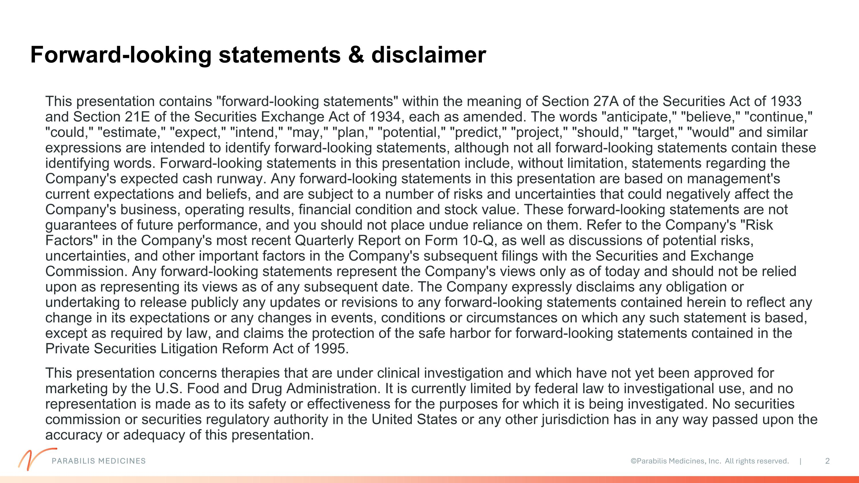
Forward-looking statements & disclaimer PARABILIS MEDICINES This presentation contains "forward-looking statements" within the meaning of Section 27A of the Securities Act of 1933 and Section 21E of the Securities Exchange Act of 1934, each as amended. The words "anticipate," "believe," "continue," "could," "estimate," "expect," "intend," "may," "plan," "potential," "predict," "project," "should," "target," "would" and similar expressions are intended to identify forward-looking statements, although not all forward-looking statements contain these identifying words. Forward-looking statements in this presentation include, without limitation, statements regarding the Company's expected cash runway. Any forward-looking statements in this presentation are based on management's current expectations and beliefs, and are subject to a number of risks and uncertainties that could negatively affect the Company's business, operating results, financial condition and stock value. These forward-looking statements are not guarantees of future performance, and you should not place undue reliance on them. Refer to the Company's "Risk Factors" in the Company's most recent Quarterly Report on Form 10-Q, as well as discussions of potential risks, uncertainties, and other important factors in the Company's subsequent filings with the Securities and Exchange Commission. Any forward-looking statements represent the Company's views only as of today and should not be relied upon as representing its views as of any subsequent date. The Company expressly disclaims any obligation or undertaking to release publicly any updates or revisions to any forward-looking statements contained herein to reflect any change in its expectations or any changes in events, conditions or circumstances on which any such statement is based, except as required by law, and claims the protection of the safe harbor for forward-looking statements contained in the Private Securities Litigation Reform Act of 1995. This presentation concerns therapies that are under clinical investigation and which have not yet been approved for marketing by the U.S. Food and Drug Administration. It is currently limited by federal law to investigational use, and no representation is made as to its safety or effectiveness for the purposes for which it is being investigated. No securities commission or securities regulatory authority in the United States or any other jurisdiction has in any way passed upon the accuracy or adequacy of this presentation.

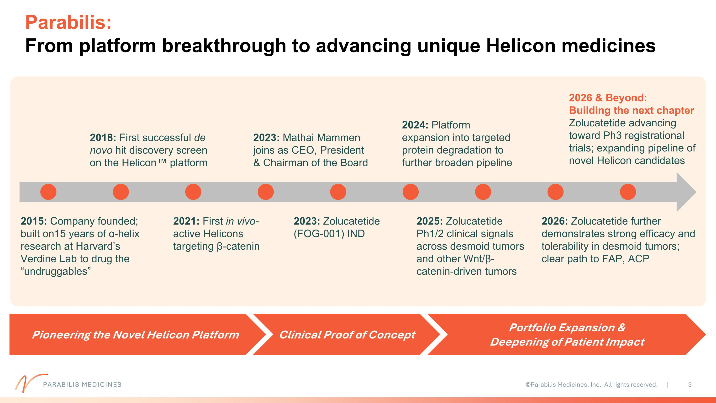
2015: Company founded; built on15 years of α-helix research at Harvard’s Verdine Lab to drug the “undruggables” 2024: Platform expansion into targeted protein degradation to further broaden pipeline 2018: First successful de novo hit discovery screen on the Helicon platform 2021: First in vivo-active Helicons targeting β-catenin 2025: Zolucatetide Ph1/2 clinical signals across desmoid tumors and other Wnt/β-catenin-driven tumors 2023: Mathai Mammen joins as CEO, President & Chairman of the Board 2026: Zolucatetide further demonstrates strong efficacy and tolerability in desmoid tumors; clear path to FAP, ACP 2026 & Beyond: Building the next chapter Zolucatetide advancing toward Ph3 registrational trials; expanding pipeline of novel Helicon candidates PARABILIS MEDICINES Parabilis: ?From platform breakthrough to advancing unique Helicon medicines Pioneering the Novel Helicon Platform Clinical Proof of Concept Portfolio Expansion & Deepening of Patient Impact 2023: Zolucatetide (FOG-001) IND

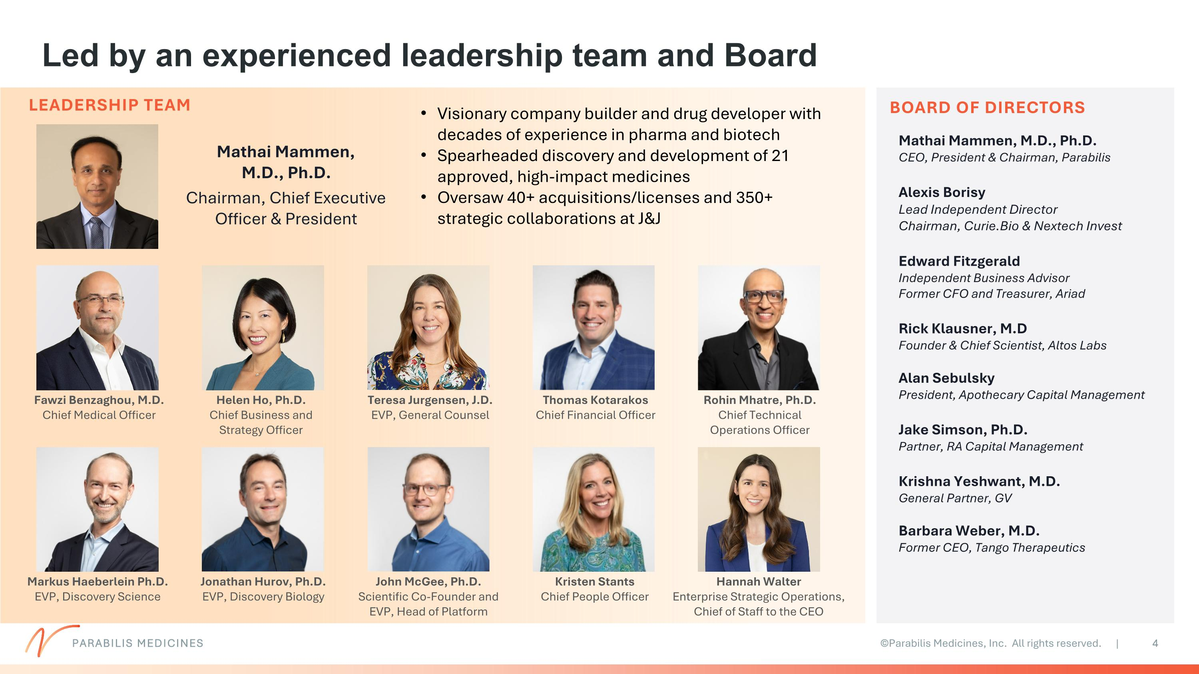
Led by an experienced leadership team and Board 4 Mathai Mammen, M.D., Ph.D. Chairman, Chief Executive Officer & President Kristen Stants Chief People Officer John McGee, Ph.D. Scientific Co-Founder and EVP, Head of Platform Fawzi Benzaghou, M.D. Chief Medical Officer BOARD OF DIRECTORS Mathai Mammen, M.D., Ph.D. CEO, President & Chairman, Parabilis Alexis Borisy Lead Independent Director Chairman, Curie.Bio & Nextech Invest Edward Fitzgerald Independent Business Advisor Former CFO and Treasurer, Ariad Rick Klausner, M.D Founder & Chief Scientist, Altos Labs Alan Sebulsky President, Apothecary Capital Management Jake Simson, Ph.D. Partner, RA Capital Management Krishna Yeshwant, M.D. General Partner, GV Barbara Weber, M.D. Former CEO, Tango Therapeutics Helen Ho, Ph.D. Chief Business and Strategy Officer Hannah Walter Enterprise Strategic Operations, Chief of Staff to the CEO Visionary company builder and drug developer with decades of experience in pharma and biotech Spearheaded discovery and development of 21 approved, high-impact medicines Oversaw 40+ acquisitions/licenses and 350+ strategic collaborations at J&J LEADERSHIP TEAM Teresa Jurgensen, J.D. EVP, General Counsel Markus Haeberlein Ph.D. EVP, Discovery Science Rohin Mhatre, Ph.D. Chief Technical Operations Officer Jonathan Hurov, Ph.D. EVP, Discovery Biology Thomas Kotarakos Chief Financial Officer PARABILIS MEDICINES

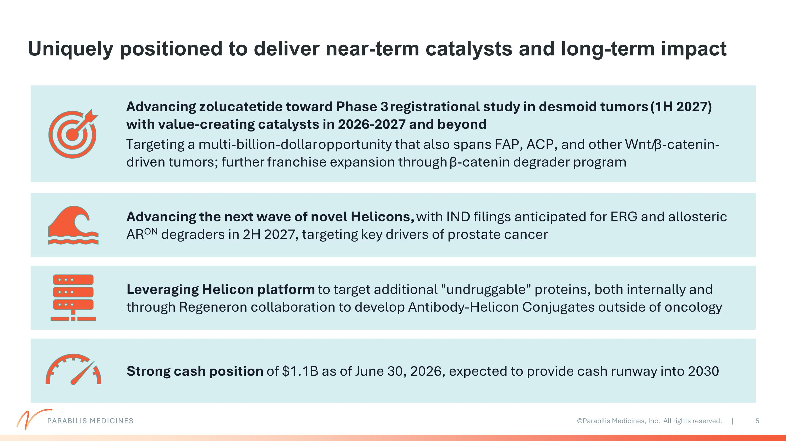
Uniquely positioned to deliver near-term catalysts and long-term impact Advancing zolucatetide toward Phase 3 registrational study in desmoid tumors (1H 2027) with value-creating catalysts in 2026-2027 and beyond Targeting a multi-billion-dollar opportunity that also spans FAP, ACP, and other Wnt/ β-catenin-driven tumors; further franchise expansion through β-catenin degrader program Advancing the next wave of novel Helicons, with IND filings anticipated for ERG and allosteric ARON degraders in 2H 2027, targeting key drivers of prostate cancer Leveraging Helicon platform to target additional "undruggable" proteins, both internally and through Regeneron collaboration to develop Antibody-Helicon Conjugates outside of oncology Strong cash position of $1.1B as of June 30, 2026, expected to provide cash runway into 2030 PARABILIS MEDICINES

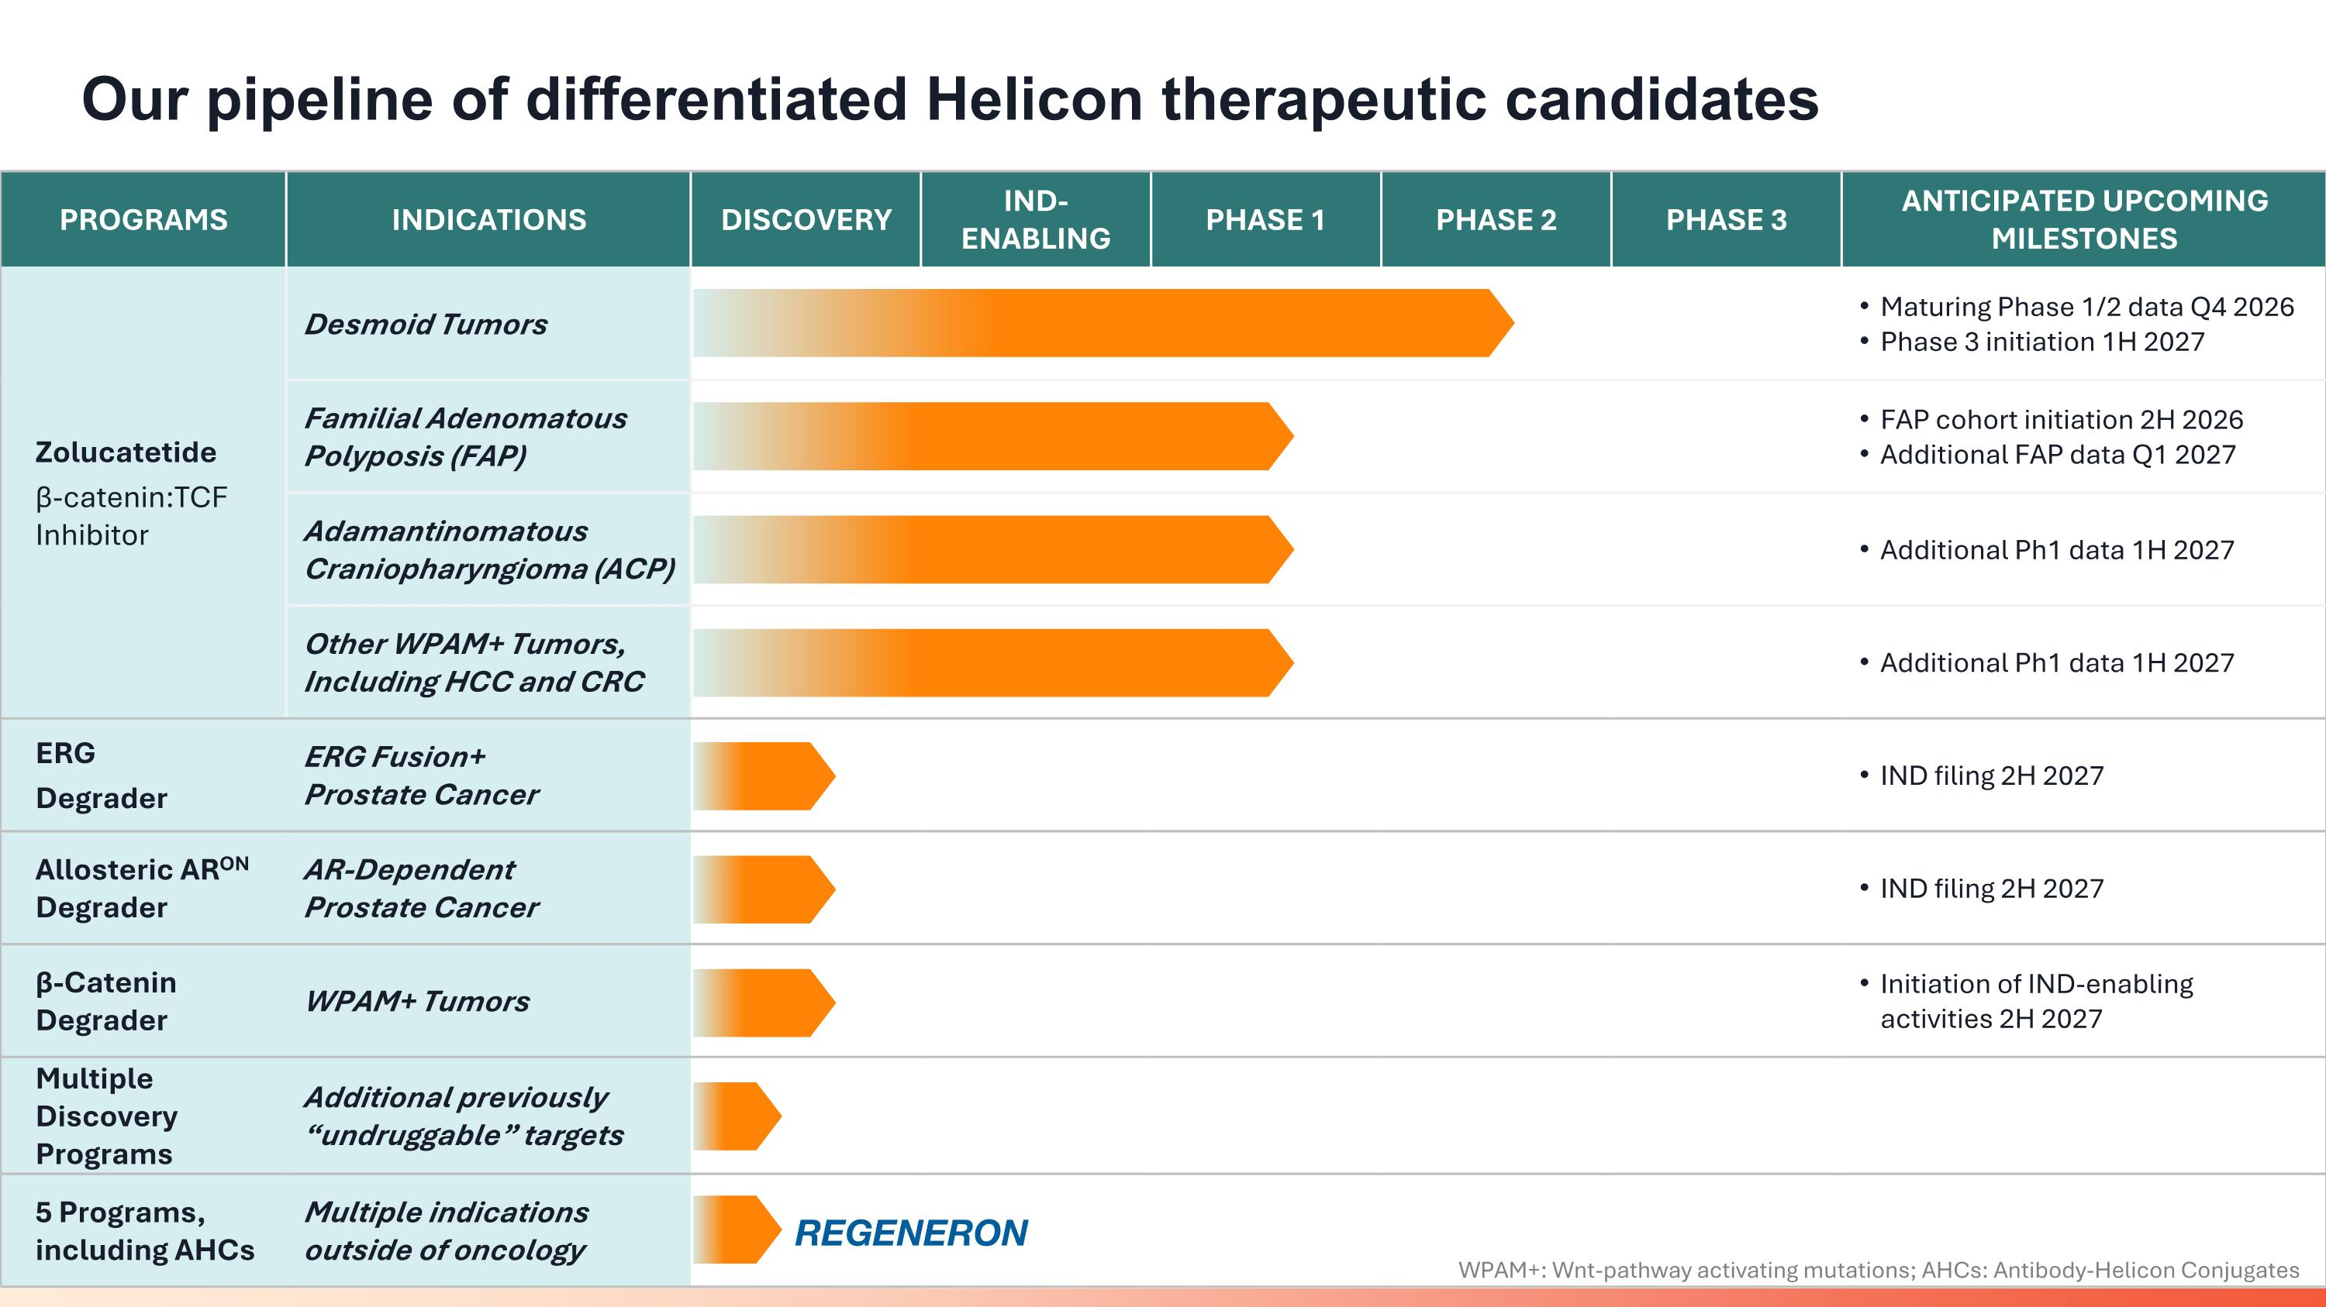
Our pipeline of differentiated Helicon therapeutic candidates PARABILIS MEDICINES PROGRAMS INDICATIONS DISCOVERY IND- ENABLING PHASE 1 PHASE 2 PHASE 3 ANTICIPATED UPCOMING MILESTONES Zolucatetide β-catenin:TCF Inhibitor Desmoid Tumors Maturing Phase 1/2 data Q4 2026 Phase 3 initiation 1H 2027 Familial Adenomatous Polyposis (FAP) FAP cohort initiation 2H 2026 Additional FAP data Q1 2027 Adamantinomatous Craniopharyngioma (ACP) Additional Ph1 data 1H 2027 Other WPAM+ Tumors, Including HCC and CRC Additional Ph1 data 1H 2027 ERG Degrader ERG Fusion+ Prostate Cancer IND filing 2H 2027 Allosteric ARON Degrader AR-Dependent Prostate Cancer IND filing 2H 2027 β-Catenin?Degrader WPAM+ Tumors Initiation of IND-enabling activities 2H 2027 Multiple Discovery Programs Additional previously “undruggable” targets 5 Programs, including AHCs Multiple indications outside of oncology WPAM+: Wnt-pathway activating mutations; AHCs: Antibody-Helicon Conjugates

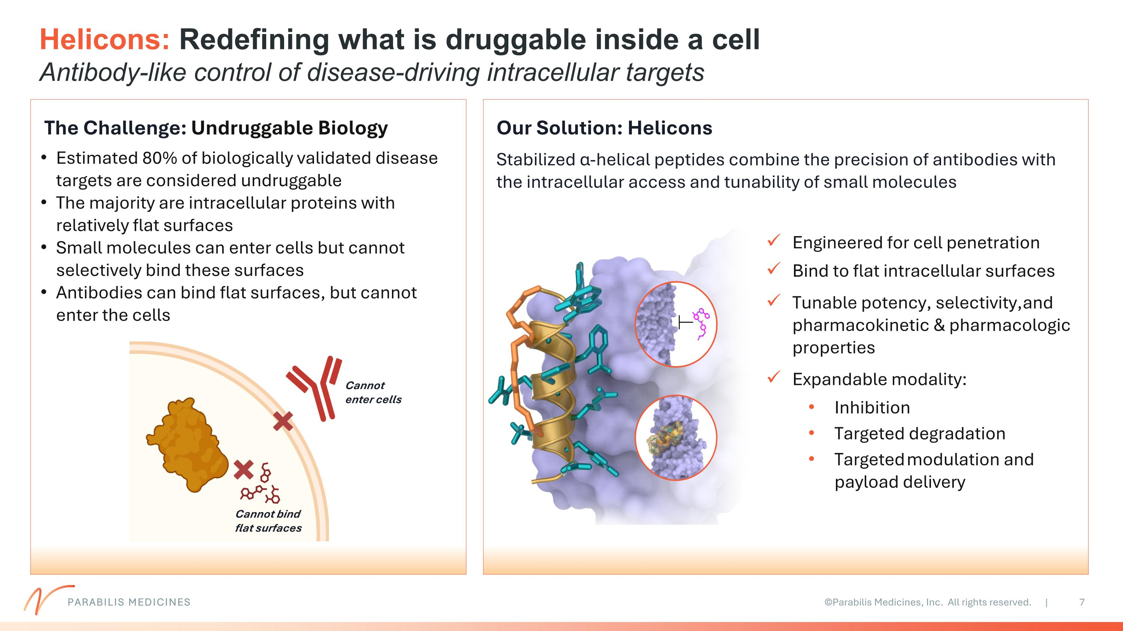
Helicons: Redefining what is druggable inside a cell?Antibody-like control of disease-driving intracellular targets The Challenge: Undruggable Biology Our Solution: Helicons Stabilized α-helical peptides combine the precision of antibodies with the intracellular access and tunability of small molecules Cannot enter cells Cannot bind flat surfaces Engineered for cell penetration Bind to flat intracellular surfaces Tunable potency, selectivity, and pharmacokinetic & pharmacologic properties Expandable modality: Inhibition Targeted degradation Targeted modulation and payload delivery Estimated 80% of biologically validated disease targets are considered undruggable The majority are intracellular proteins with relatively flat surfaces Small molecules can enter cells but cannot selectively bind these surfaces Antibodies can bind flat surfaces, but cannot enter the cells PARABILIS MEDICINES

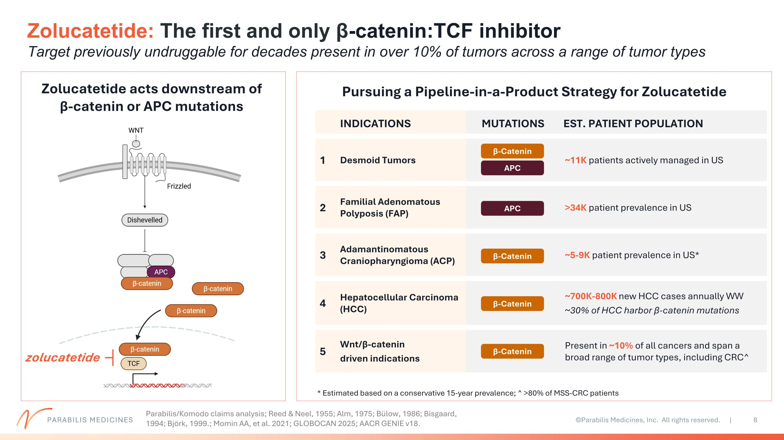
PARABILIS MEDICINES Zolucatetide: The first and only β-catenin:TCF inhibitor ?Target previously undruggable for decades present in over 10% of tumors across a range of tumor types Zolucatetide acts downstream of ?β-catenin or APC mutations zolucatetide Pursuing a Pipeline-in-a-Product Strategy for Zolucatetide INDICATIONS MUTATIONS EST. PATIENT POPULATION 1 Desmoid Tumors ~11K patients actively managed in US 2 Familial Adenomatous Polyposis (FAP) >34K patient prevalence in US 3 Adamantinomatous Craniopharyngioma (ACP) ~5-9K patient prevalence in US* 4 Hepatocellular Carcinoma (HCC) ~700K-800K new HCC cases annually WW ~30% of HCC harbor β-catenin mutations 5 Wnt/β-catenin driven indications Present in ~10% of all cancers and span a broad range of tumor types, including CRC^ β-Catenin APC APC β-Catenin * Estimated based on a conservative 15-year prevalence; ^ >80% of MSS-CRC patients β-Catenin β-Catenin Parabilis/Komodo claims analysis; Reed & Neel, 1955; Alm, 1975; Bülow, 1986; Bisgaard, 1994; Björk, 1999.; Momin AA, et al. 2021; GLOBOCAN 2025; AACR GENIE v18.

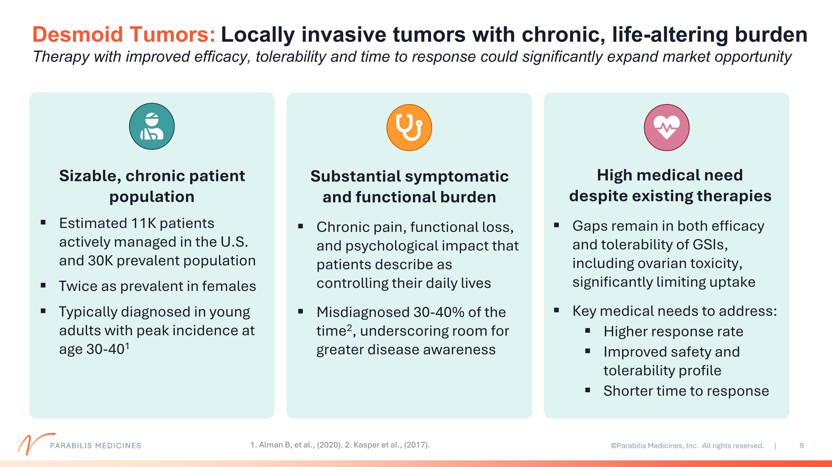
Desmoid Tumors: Locally invasive tumors with chronic, life-altering burden ?Therapy with improved efficacy, tolerability and time to response could significantly expand market opportunity Sizable, chronic patient population Estimated 11K patients actively managed in the U.S. and 30K prevalent population Twice as prevalent in females Typically diagnosed in young adults with peak incidence at age 30-401 Substantial symptomatic and functional burden Chronic pain, functional loss, and psychological impact that patients describe as controlling their daily lives Misdiagnosed 30-40% of the time2, underscoring room for greater disease awareness High medical need ?despite existing therapies Gaps remain in both efficacy and tolerability of GSIs, including ovarian toxicity, significantly limiting uptake Key medical needs to address: Higher response rate Improved safety and tolerability profile Shorter time to response 1. Alman B, et al., (2020). 2. Kasper et al., (2017). PARABILIS MEDICINES

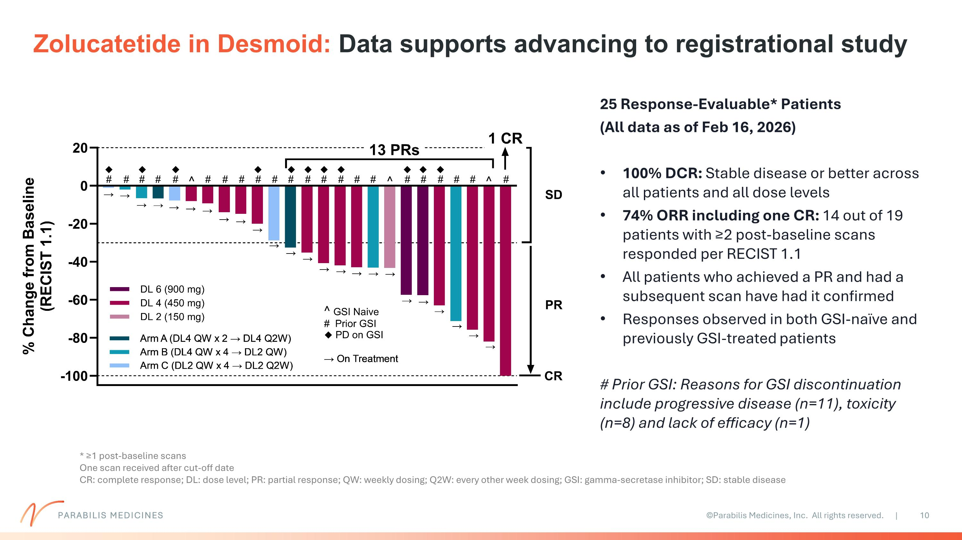
Zolucatetide in Desmoid: Data supports advancing to registrational study 25 Response-Evaluable* Patients (All data as of Feb 16, 2026) 100% DCR: Stable disease or better across all patients and all dose levels 74% ORR including one CR: 14 out of 19 patients with ≥2 post-baseline scans responded per RECIST 1.1 All patients who achieved a PR and had a subsequent scan have had it confirmed Responses observed in both GSI-naïve and previously GSI-treated patients # Prior GSI: Reasons for GSI discontinuation include progressive disease (n=11), toxicity (n=8) and lack of efficacy (n=1) * ≥1 post-baseline scans One scan received after cut-off date CR: complete response; DL: dose level; PR: partial response; QW: weekly dosing; Q2W: every other week dosing; GSI: gamma-secretase inhibitor; SD: stable disease PARABILIS MEDICINES

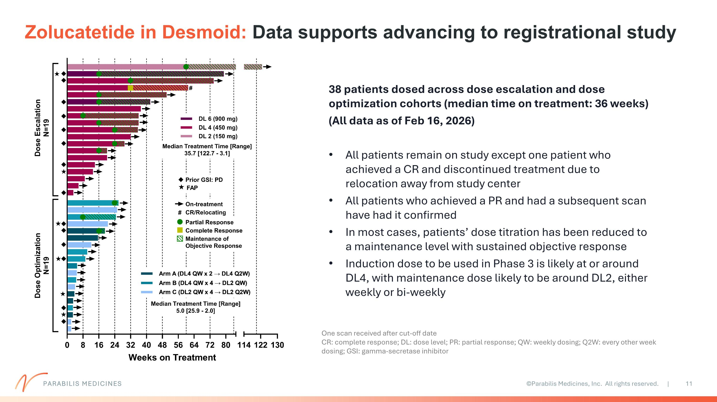
Zolucatetide in Desmoid: Data supports advancing to registrational study One scan received after cut-off date CR: complete response; DL: dose level; PR: partial response; QW: weekly dosing; Q2W: every other week dosing; GSI: gamma-secretase inhibitor 38 patients dosed across dose escalation and dose optimization cohorts (median time on treatment: 36 weeks) (All data as of Feb 16, 2026) All patients remain on study except one patient who achieved a CR and discontinued treatment due to relocation away from study center All patients who achieved a PR and had a subsequent scan have had it confirmed In most cases, patients’ dose titration has been reduced to a maintenance level with sustained objective response Induction dose to be used in Phase 3 is likely at or around DL4, with maintenance dose likely to be around DL2, either weekly or bi-weekly PARABILIS MEDICINES

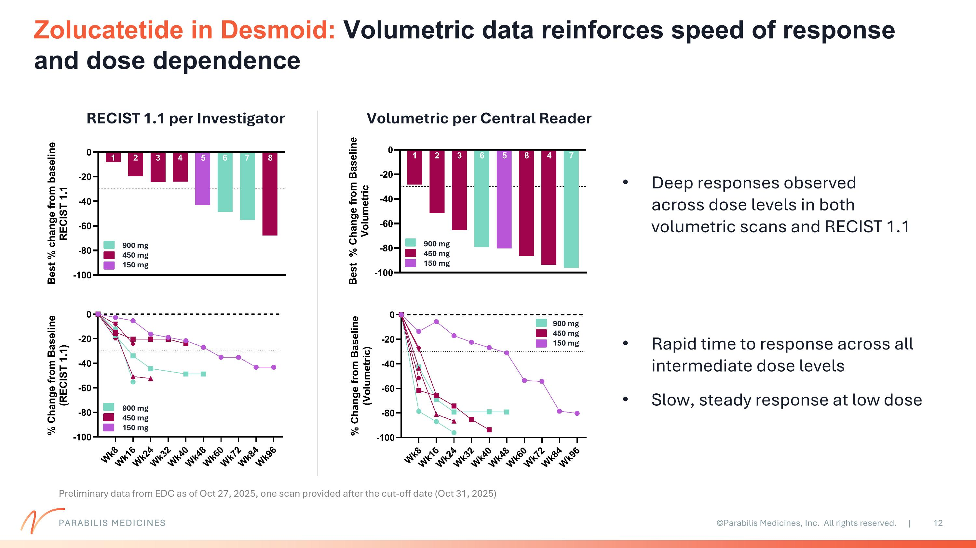
Zolucatetide in Desmoid: Volumetric data reinforces speed of response and dose dependence RECIST 1.1 per Investigator Volumetric per Central Reader Preliminary data from EDC as of Oct 27, 2025, one scan provided after the cut-off date (Oct 31, 2025) 900 mg 450 mg 150 mg 900 mg 450 mg 150 mg 900 mg 450 mg 150 mg 900 mg 450 mg 150 mg Rapid time to response across all intermediate dose levels Slow, steady response at low dose Deep responses observed across dose levels in both volumetric scans and RECIST 1.1 PARABILIS MEDICINES

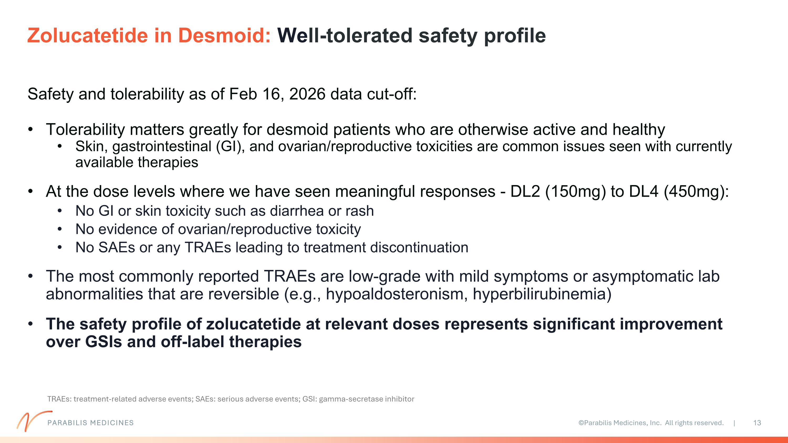
Safety and tolerability as of Feb 16, 2026 data cut-off: Tolerability matters greatly for desmoid patients who are otherwise active and healthy Skin, gastrointestinal (GI), and ovarian/reproductive toxicities are common issues seen with currently available therapies At the dose levels where we have seen meaningful responses - DL2 (150mg) to DL4 (450mg): No GI or skin toxicity such as diarrhea or rash No evidence of ovarian/reproductive toxicity No SAEs or any TRAEs leading to treatment discontinuation The most commonly reported TRAEs are low-grade with mild symptoms or asymptomatic lab abnormalities that are reversible (e.g., hypoaldosteronism, hyperbilirubinemia) The safety profile of zolucatetide at relevant doses represents significant improvement over GSIs and off-label therapies Zolucatetide in Desmoid: Well-tolerated safety profile TRAEs: treatment-related adverse events; SAEs: serious adverse events; GSI: gamma-secretase inhibitor PARABILIS MEDICINES

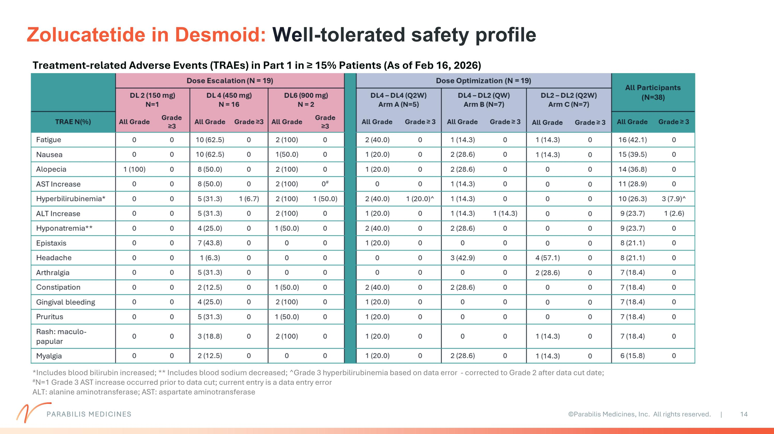
Zolucatetide in Desmoid: Well-tolerated safety profile *Includes blood bilirubin increased; ** Includes blood sodium decreased; ^Grade 3 hyperbilirubinemia based on data error - corrected to Grade 2 after data cut date; #N=1 Grade 3 AST increase occurred prior to data cut; current entry is a data entry error ALT: alanine aminotransferase; AST: aspartate aminotransferase Treatment-related Adverse Events (TRAEs) in Part 1 in ≥ 15% Patients (As of Feb 16, 2026) PARABILIS MEDICINES

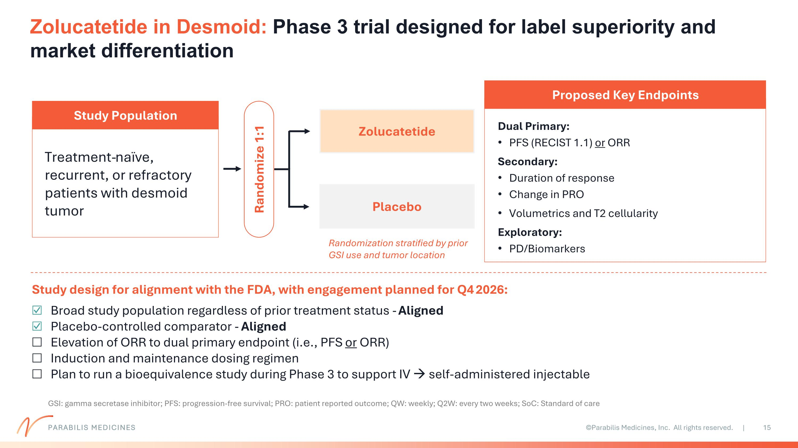
Placebo Zolucatetide Zolucatetide in Desmoid: Phase 3 trial designed for label superiority and market differentiation Treatment-naïve, recurrent, or refractory patients with desmoid tumor Study Population Study design for alignment with the FDA, with engagement planned for Q4 2026: Broad study population regardless of prior treatment status - Aligned Placebo-controlled comparator - Aligned Elevation of ORR to dual primary endpoint (i.e., PFS or ORR) Induction and maintenance dosing regimen Plan to run a bioequivalence study during Phase 3 to support IV → self-administered injectable Dual Primary: PFS (RECIST 1.1) or ORR Secondary: Duration of response Change in PRO Volumetrics and T2 cellularity Exploratory: PD/Biomarkers Proposed Key Endpoints Randomize 1:1 Randomization stratified by prior GSI use and tumor location GSI: gamma secretase inhibitor; PFS: progression-free survival; PRO: patient reported outcome; QW: weekly; Q2W: every two weeks; SoC: Standard of care PARABILIS MEDICINES

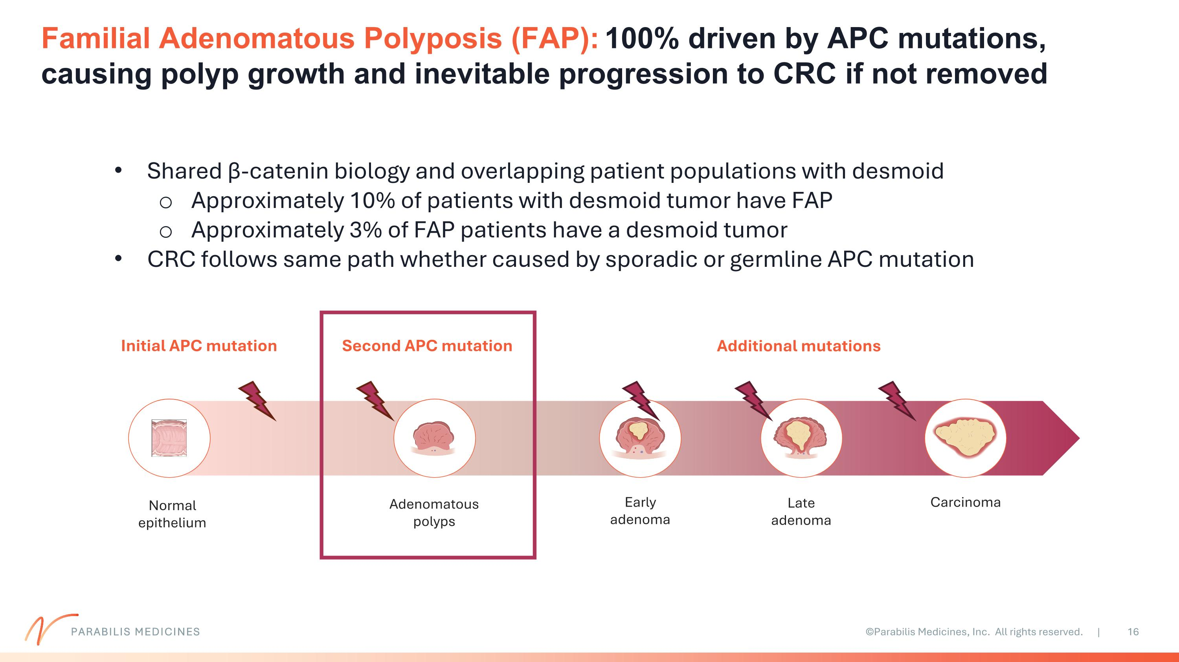
Familial Adenomatous Polyposis (FAP): 100% driven by APC mutations, causing polyp growth and inevitable progression to CRC if not removed Shared β-catenin biology and overlapping patient populations with desmoid Approximately 10% of patients with desmoid tumor have FAP Approximately 3% of FAP patients have a desmoid tumor CRC follows same path whether caused by sporadic or germline APC mutation Normal epithelium Initial APC mutation Adenomatous polyps Carcinoma Second APC mutation Late adenoma Early adenoma Additional mutations PARABILIS MEDICINES

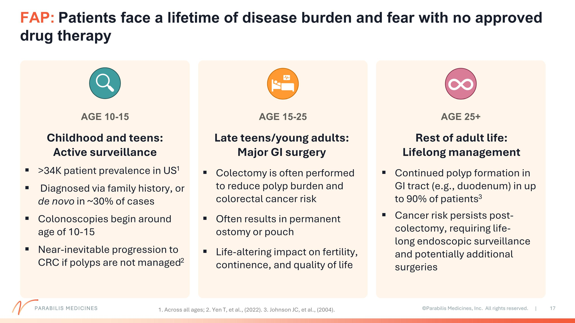
FAP: Patients face a lifetime of disease burden and fear with no approved drug therapy Childhood and teens: Active surveillance >34K patient prevalence in US1 Diagnosed via family history, or de novo in ~30% of cases Colonoscopies begin around age of 10-15 Near-inevitable progression to CRC if polyps are not managed2 Late teens/young adults: Major GI surgery Colectomy is often performed to reduce polyp burden and colorectal cancer risk Often results in permanent ostomy or pouch Life-altering impact on fertility, continence, and quality of life Rest of adult life: Lifelong management Continued polyp formation in GI tract (e.g., duodenum) in up to 90% of patients3 Cancer risk persists post-colectomy, requiring life-long endoscopic surveillance and potentially additional surgeries AGE 10-15 AGE 15-25 AGE 25+ 1. Across all ages; 2. Yen T, et al., (2022). 3. Johnson JC, et al., (2004). PARABILIS MEDICINES

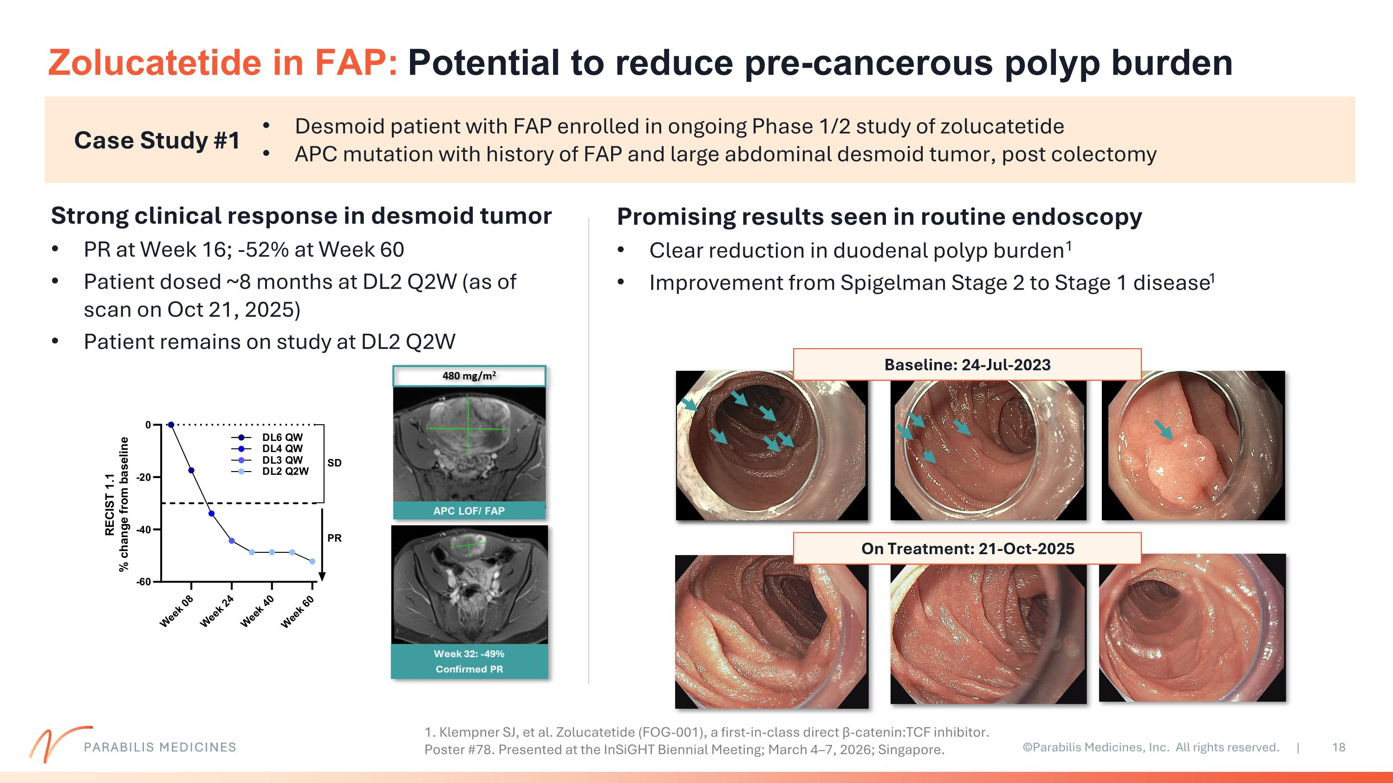
Zolucatetide in FAP: Potential to reduce pre-cancerous polyp burden Case Study #1 Strong clinical response in desmoid tumor PR at Week 16; -52% at Week 60 Patient dosed ~8 months at DL2 Q2W (as of scan on Oct 21, 2025) Patient remains on study at DL2 Q2W Desmoid patient with FAP enrolled in ongoing Phase 1/2 study of zolucatetide APC mutation with history of FAP and large abdominal desmoid tumor, post colectomy Promising results seen in routine endoscopy Clear reduction in duodenal polyp burden1 Improvement from Spigelman Stage 2 to Stage 1 disease1 Baseline: 24-Jul-2023 On Treatment: 21-Oct-2025 1. Klempner SJ, et al. Zolucatetide (FOG-001), a first-in-class direct β-catenin:TCF inhibitor. Poster #78. Presented at the InSiGHT Biennial Meeting; March 4–7, 2026; Singapore. PARABILIS MEDICINES

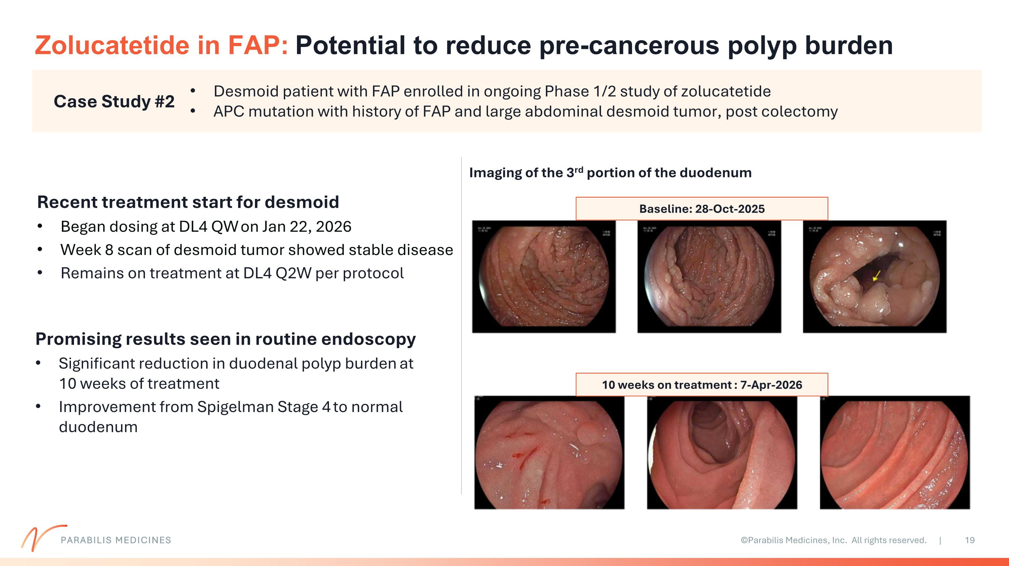
Zolucatetide in FAP: Potential to reduce pre-cancerous polyp burden Case Study #2 Recent treatment start for desmoid Began dosing at DL4 QW on Jan 22, 2026 Week 8 scan of desmoid tumor showed stable disease Remains on treatment at DL4 Q2W per protocol Desmoid patient with FAP enrolled in ongoing Phase 1/2 study of zolucatetide APC mutation with history of FAP and large abdominal desmoid tumor, post colectomy Promising results seen in routine endoscopy Significant reduction in duodenal polyp burden at 10 weeks of treatment Improvement from Spigelman Stage 4 to normal duodenum Baseline: 28-Oct-2025 10 weeks on treatment : 7-Apr-2026 PARABILIS MEDICINES Imaging of the 3rd portion of the duodenum

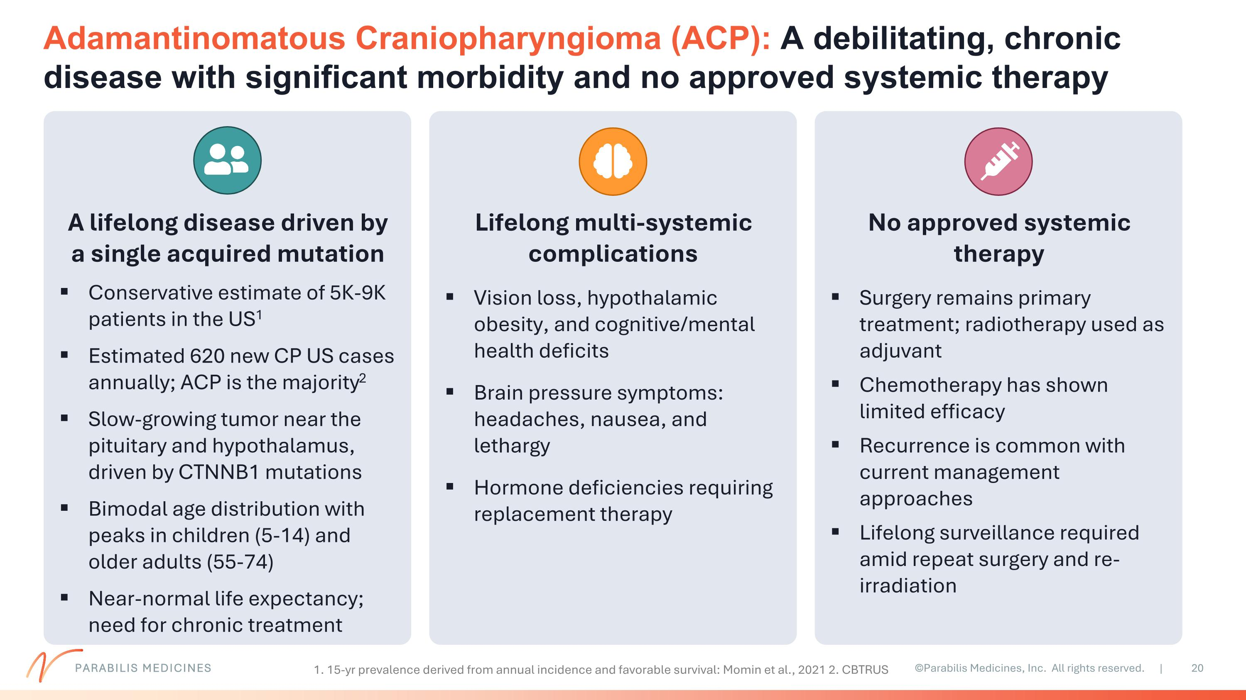
Adamantinomatous Craniopharyngioma (ACP): A debilitating, chronic disease with significant morbidity and no approved systemic therapy A lifelong disease driven by a single acquired mutation Conservative estimate of 5K-9K patients in the US1 Estimated 620 new CP US cases annually; ACP is the majority2 Slow-growing tumor near the pituitary and hypothalamus, driven by CTNNB1 mutations Bimodal age distribution with peaks in children (5-14) and older adults (55-74) Near-normal life expectancy; need for chronic treatment Lifelong multi-systemic complications Vision loss, hypothalamic obesity, and cognitive/mental health deficits Brain pressure symptoms: headaches, nausea, and lethargy Hormone deficiencies requiring replacement therapy No approved systemic therapy Surgery remains primary treatment; radiotherapy used as adjuvant Chemotherapy has shown limited efficacy Recurrence is common with current management approaches Lifelong surveillance required amid repeat surgery and re-irradiation 1. 15-yr prevalence derived from annual incidence and favorable survival: Momin et al., 2021 2. CBTRUS PARABILIS MEDICINES

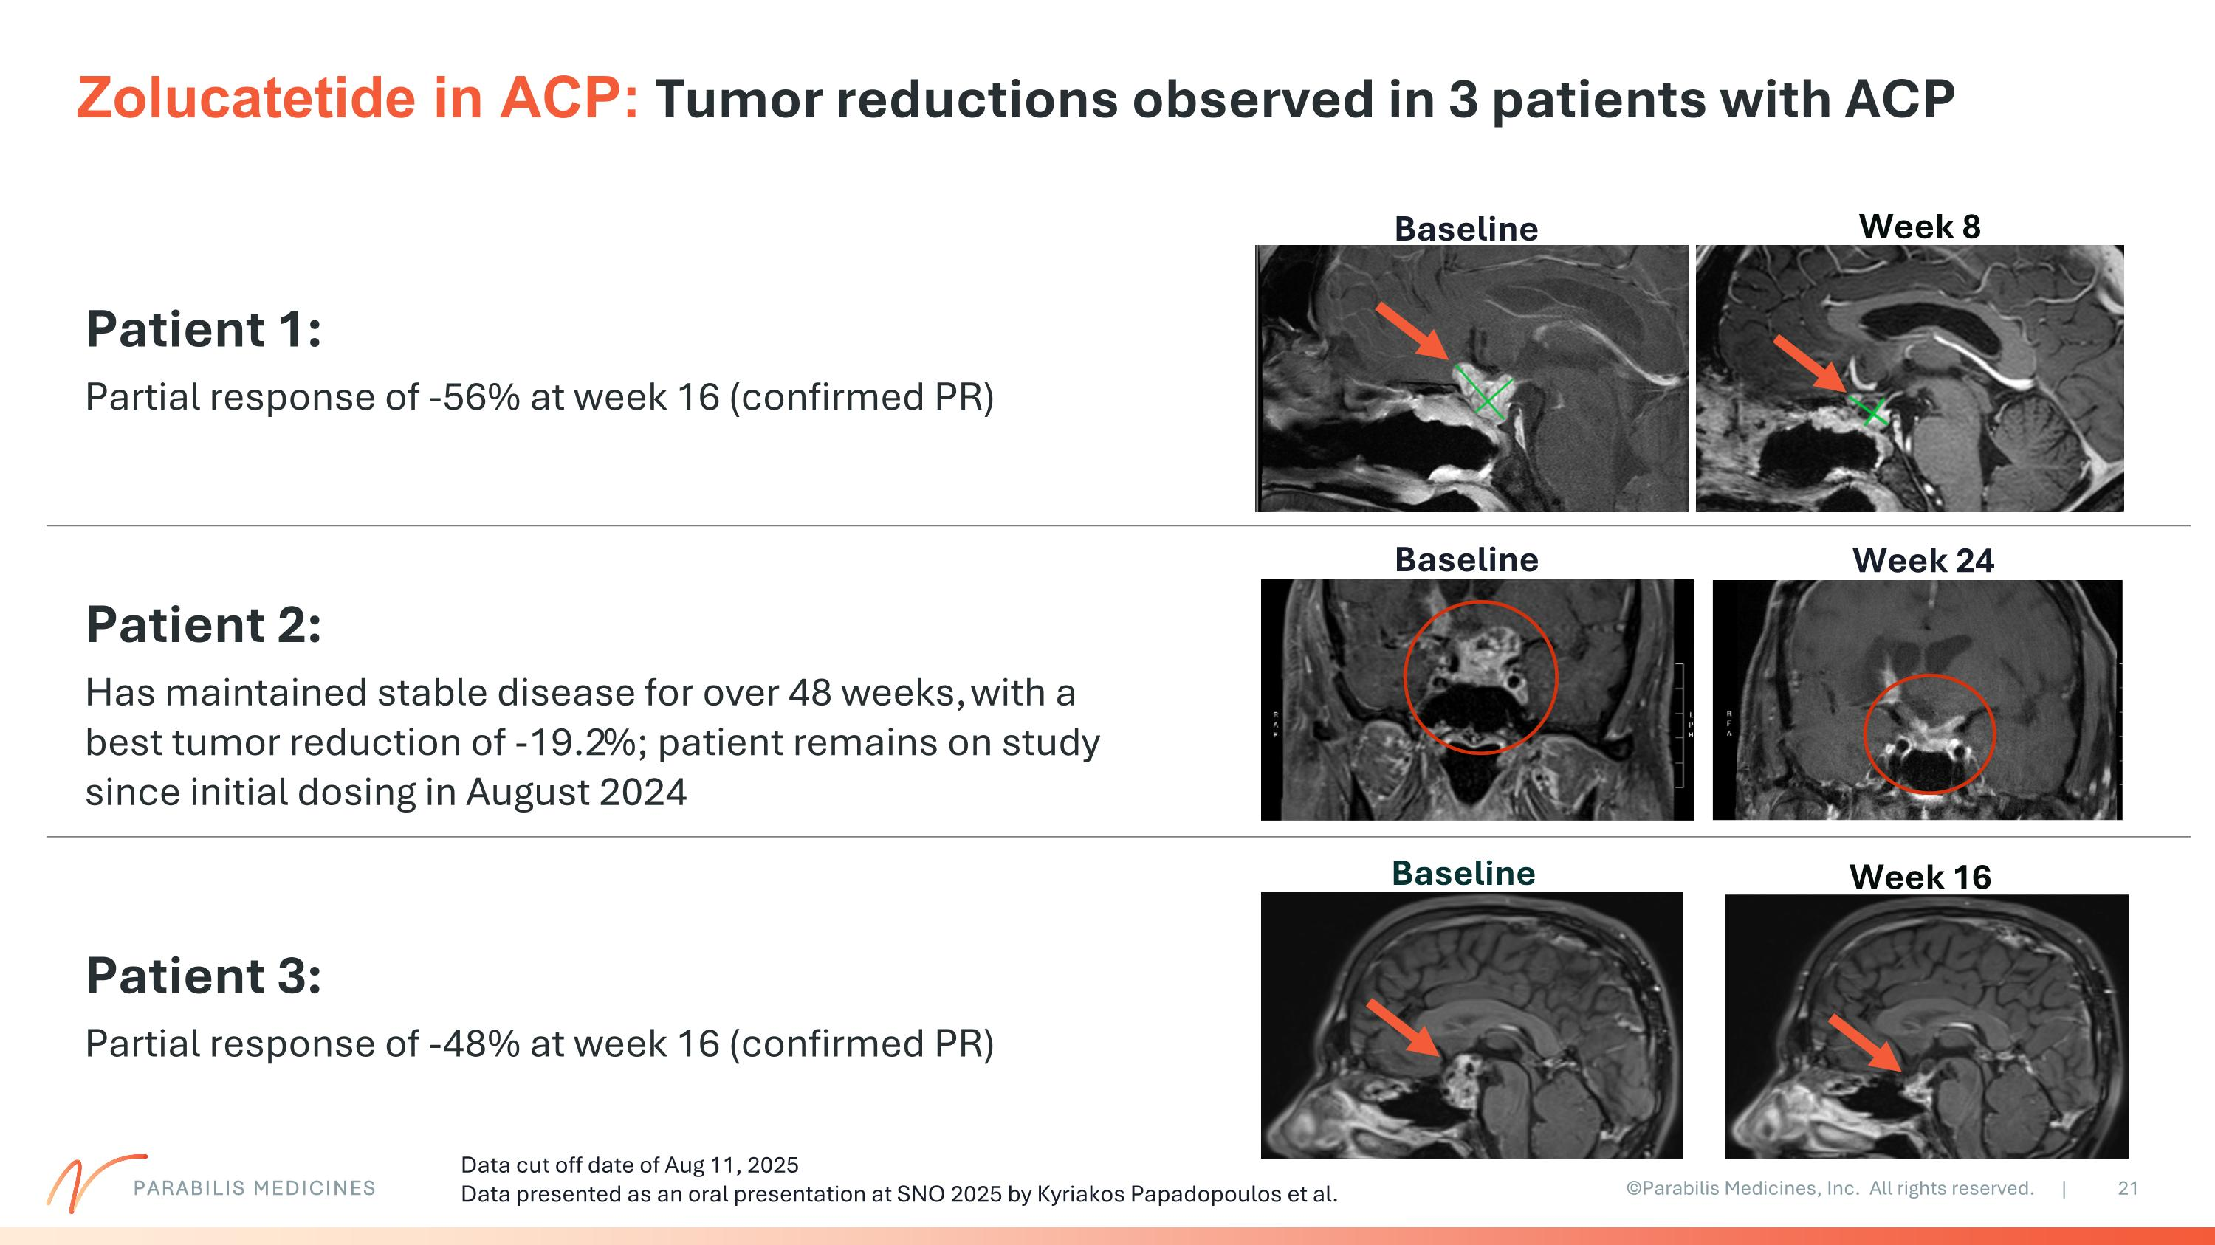
Baseline Week 16 Patient 3: Partial response of -48% at week 16 (confirmed PR) Baseline Week 24 Patient 2: Has maintained stable disease for over 48 weeks, with a best tumor reduction of -19.2%; patient remains on study since initial dosing in August 2024 Baseline Week 8 Patient 1: Partial response of -56% at week 16 (confirmed PR) Zolucatetide in ACP: Tumor reductions observed in 3 patients with ACP PARABILIS MEDICINES Data cut off date of Aug 11, 2025 Data presented as an oral presentation at SNO 2025 by Kyriakos Papadopoulos et al.

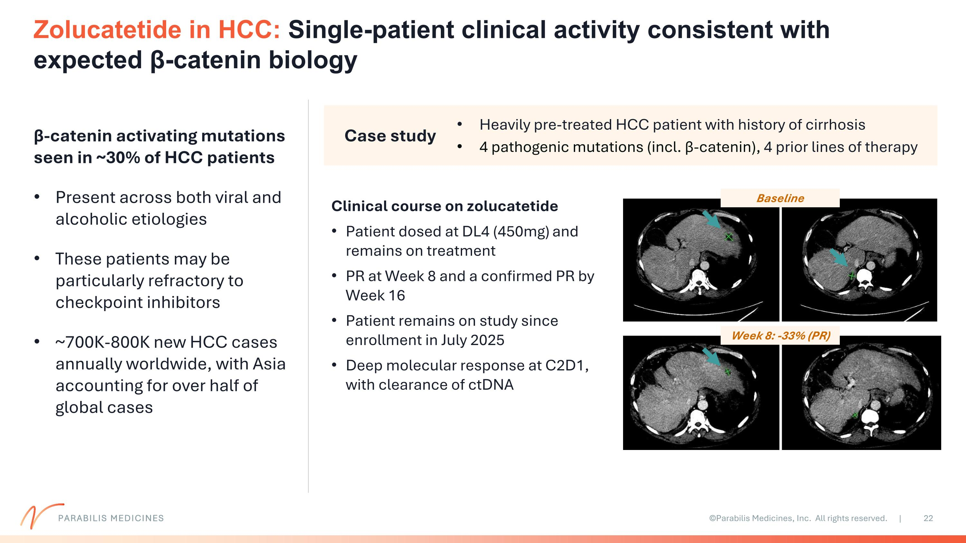
Zolucatetide in HCC: Single-patient clinical activity consistent with expected β-catenin biology Case study Heavily pre-treated HCC patient with history of cirrhosis 4 pathogenic mutations (incl. β-catenin), 4 prior lines of therapy Week 8: -33% (PR) Baseline Clinical course on zolucatetide Patient dosed at DL4 (450mg) and remains on treatment PR at Week 8 and a confirmed PR by Week 16 Patient remains on study since enrollment in July 2025 Deep molecular response at C2D1, with clearance of ctDNA β-catenin activating mutations seen in ~30% of HCC patients Present across both viral and alcoholic etiologies These patients may be particularly refractory to checkpoint inhibitors ~700K-800K new HCC cases annually worldwide, with Asia accounting for over half of global cases PARABILIS MEDICINES

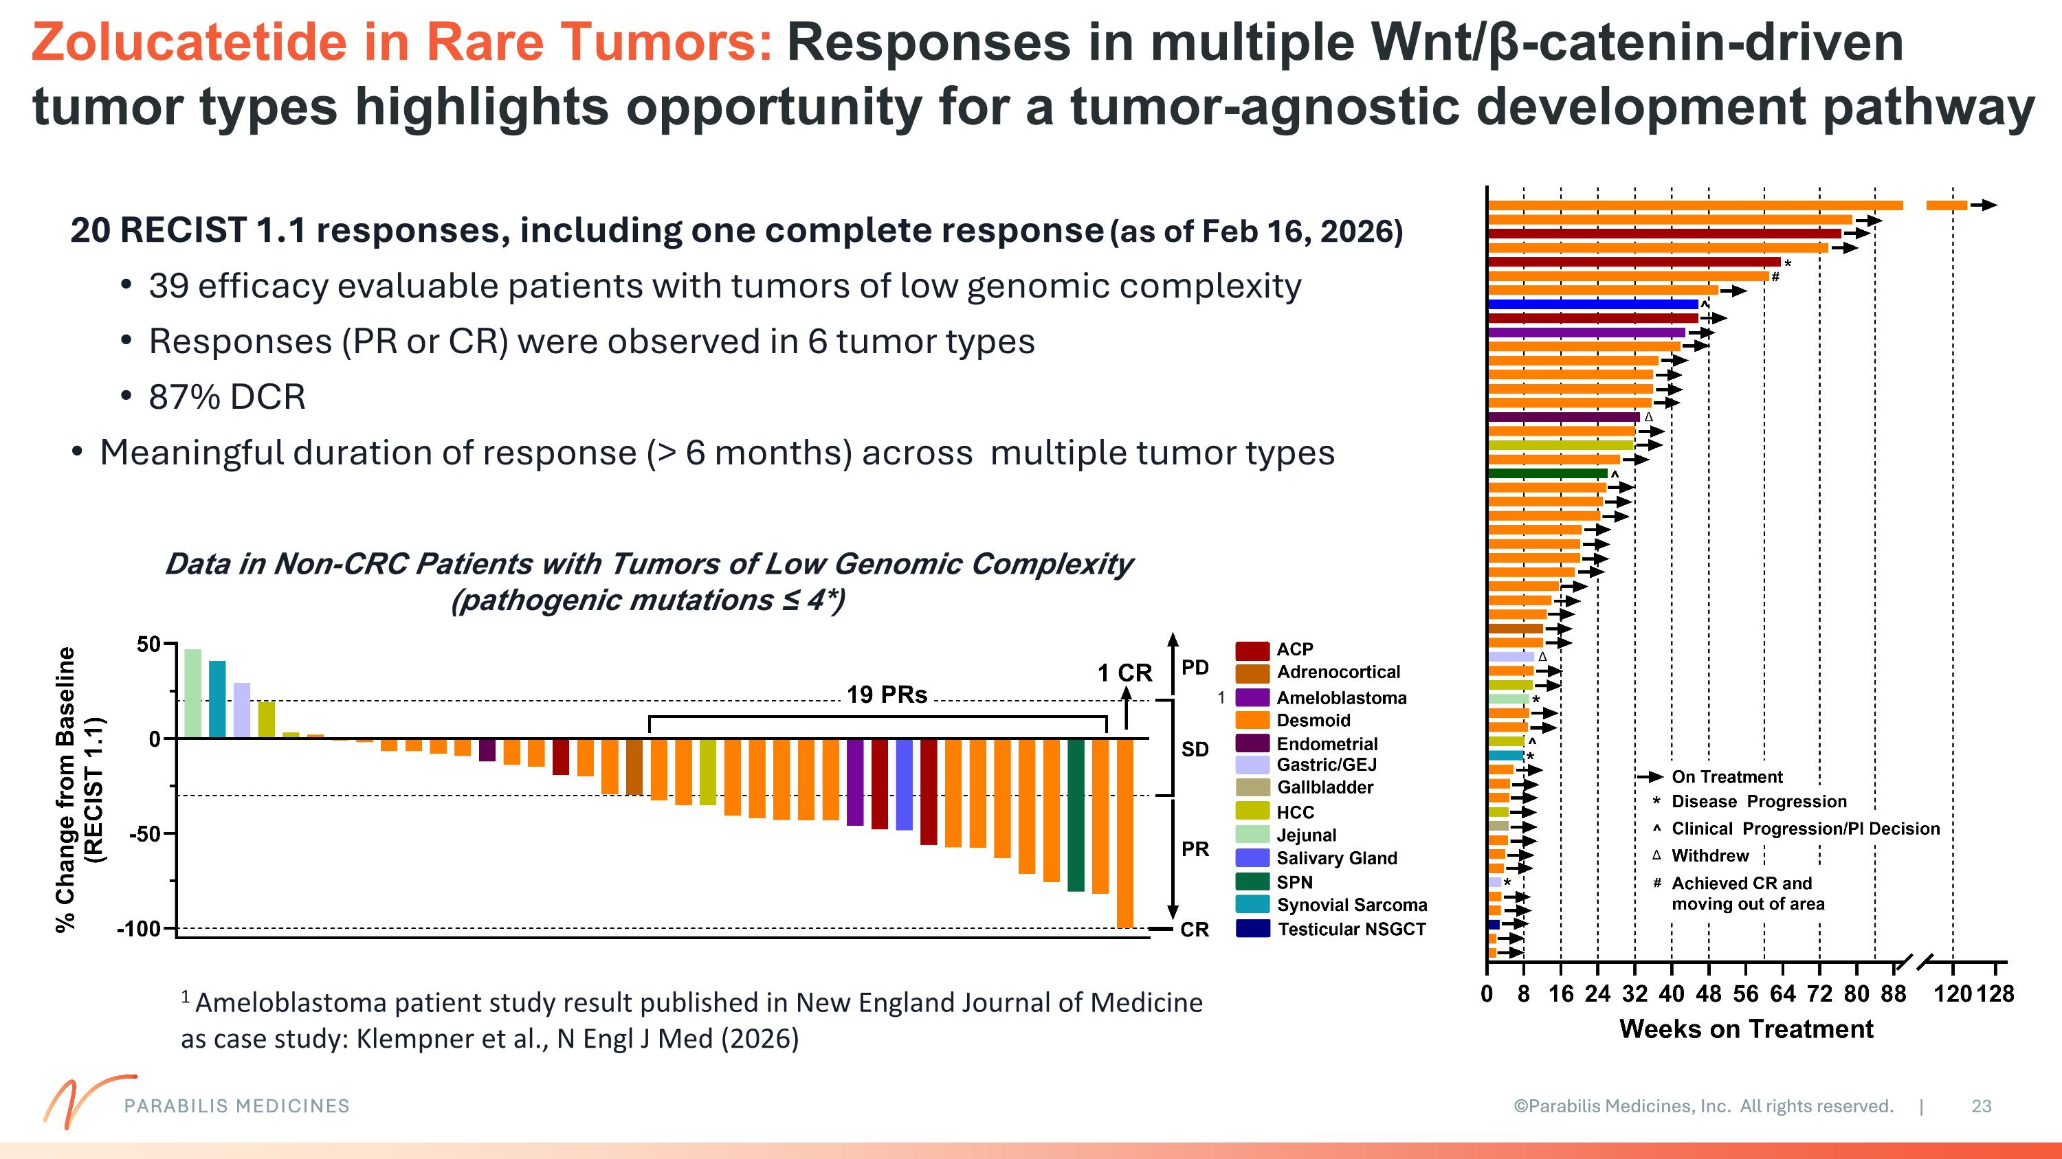
Zolucatetide in Rare Tumors: Responses in multiple Wnt/β-catenin-driven tumor types highlights opportunity for a tumor-agnostic development pathway Data in Non-CRC Patients with Tumors of Low Genomic Complexity (pathogenic mutations ≤ 4*) 20 RECIST 1.1 responses, including one complete response (as of Feb 16, 2026) 39 efficacy evaluable patients with tumors of low genomic complexity Responses (PR or CR) were observed in 6 tumor types 87% DCR Meaningful duration of response (> 6 months) across multiple tumor types 1 1 Ameloblastoma patient study result published in New England Journal of Medicine as case study: Klempner et al., N Engl J Med (2026) PARABILIS MEDICINES

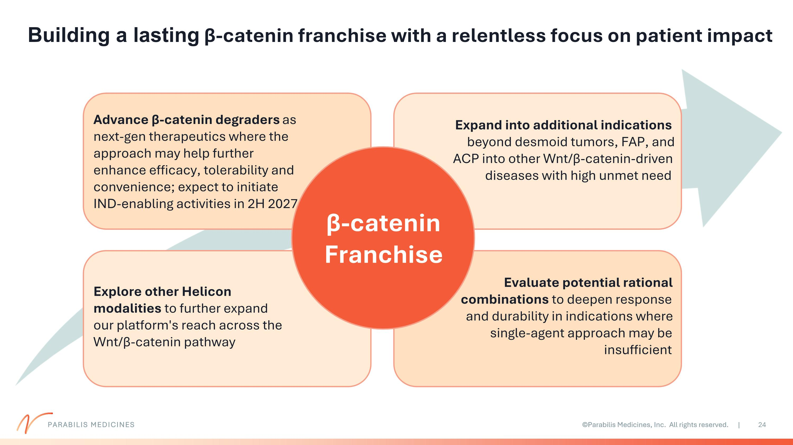
Building a lasting β-catenin franchise with a relentless focus on patient impact PARABILIS MEDICINES β-catenin Franchise Advance β-catenin degraders as next-gen therapeutics where the approach may help further enhance efficacy, tolerability and convenience; expect to initiate IND-enabling activities in 2H 2027 Explore other Helicon modalities to further expand our platform's reach across the Wnt/β-catenin pathway Expand into additional indications beyond desmoid tumors, FAP, and ACP into other Wnt/β-catenin-driven diseases with high unmet need Evaluate potential rational combinations to deepen response and durability in indications where single-agent approach may be insufficient

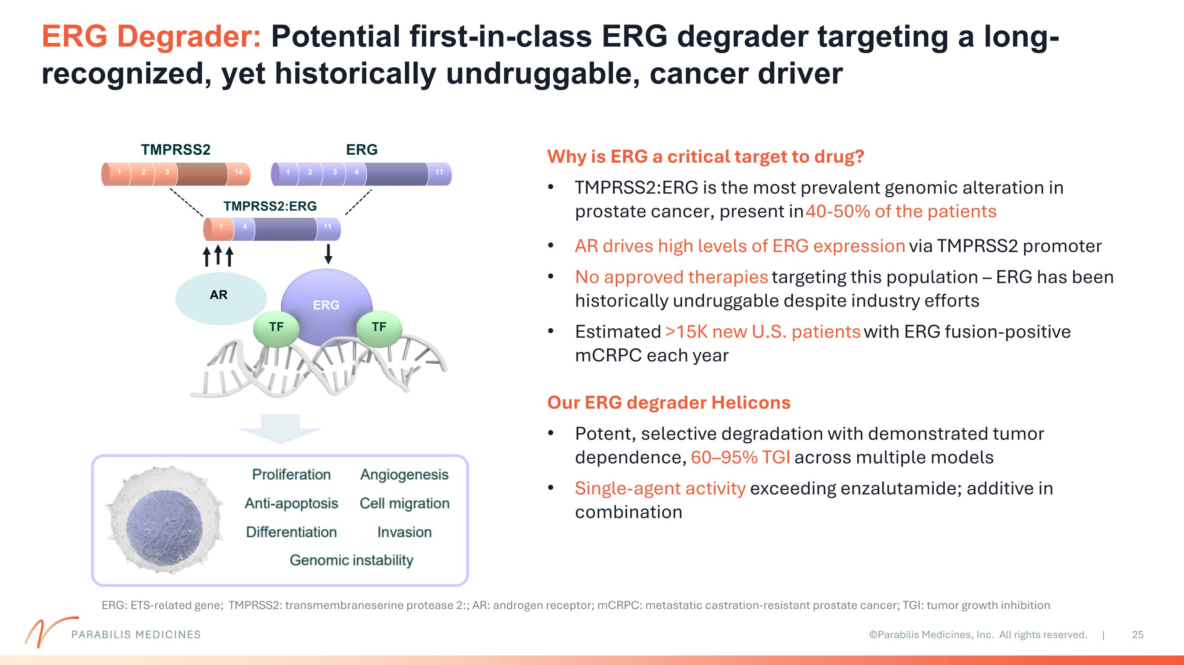
ERG Degrader: Potential first-in-class ERG degrader targeting a long-recognized, yet historically undruggable, cancer driver PARABILIS MEDICINES Why is ERG a critical target to drug? TMPRSS2:ERG is the most prevalent genomic alteration in prostate cancer, present in 40-50% of the patients AR drives high levels of ERG expression via TMPRSS2 promoter No approved therapies targeting this population – ERG has been historically undruggable despite industry efforts Estimated >15K new U.S. patients with ERG fusion-positive mCRPC each year Our ERG degrader Helicons Potent, selective degradation with demonstrated tumor dependence, 60–95% TGI across multiple models Single-agent activity exceeding enzalutamide; additive in combination ERG TF TF TMPRSS2 ERG TMPRSS2:ERG 1 2 14 3 1 2 11 3 4 1 11 4 AR ERG: ETS-related gene; TMPRSS2: transmembraneserine protease 2:; AR: androgen receptor; mCRPC: metastatic castration-resistant prostate cancer; TGI: tumor growth inhibition

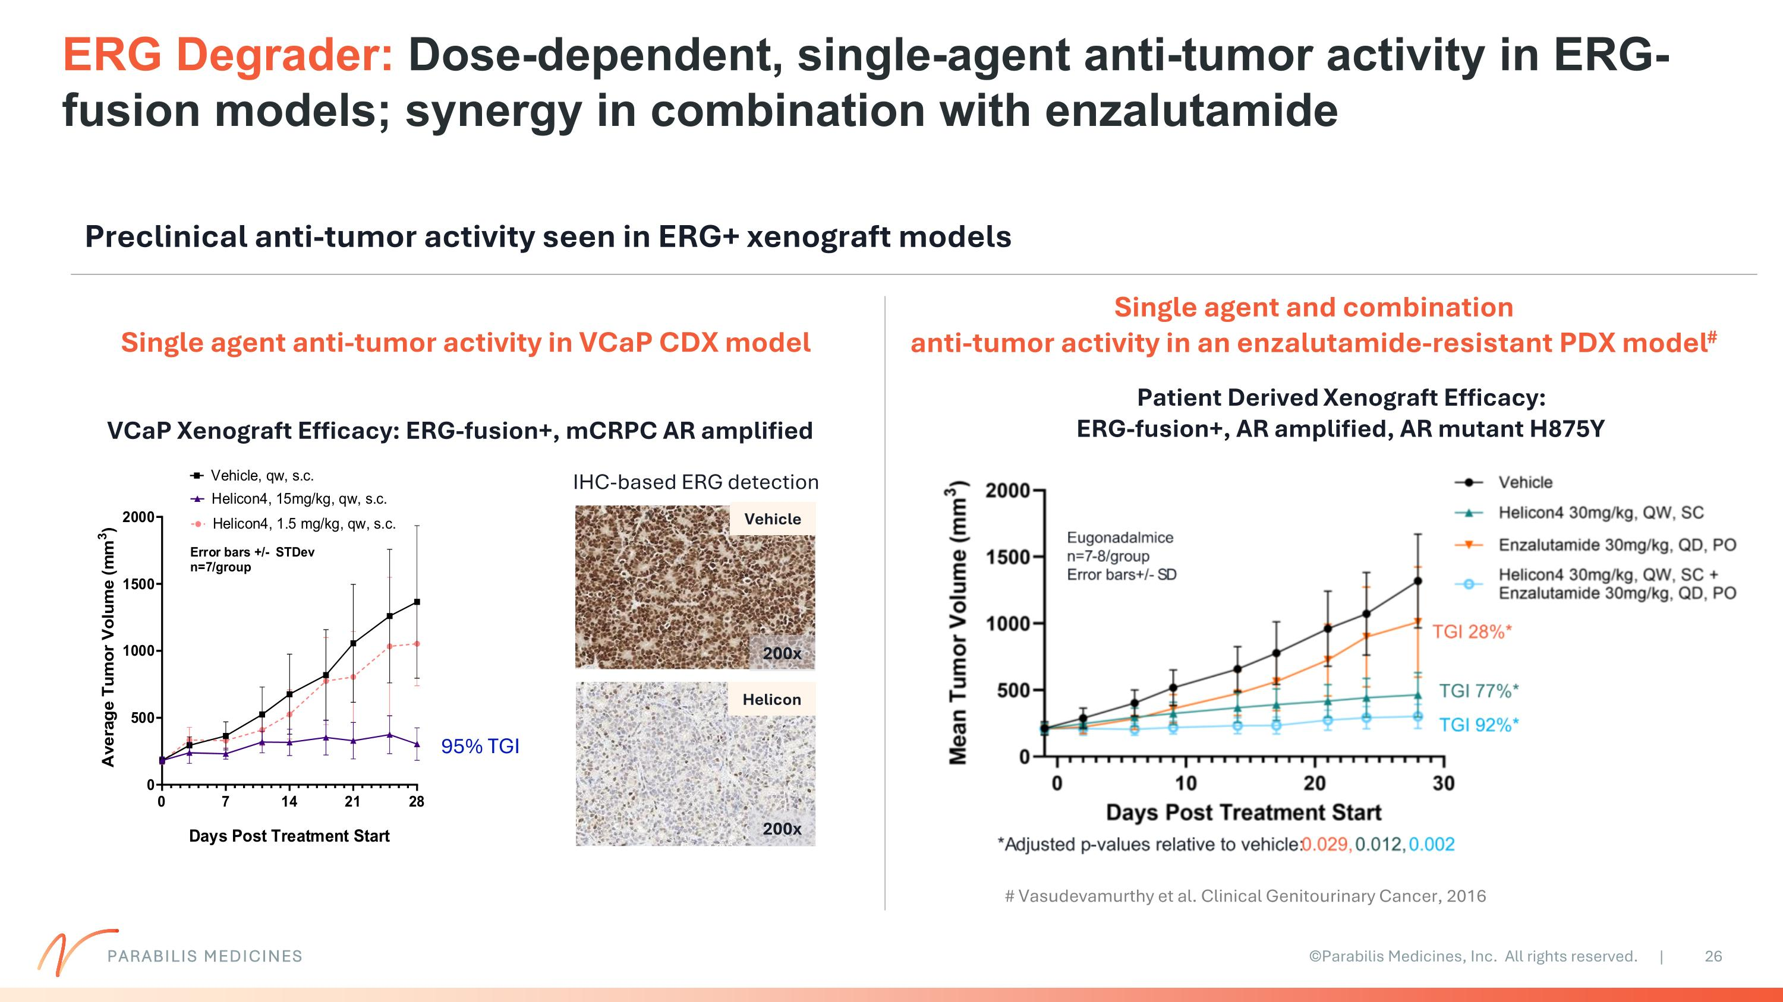
ERG Degrader: Dose-dependent, single-agent anti-tumor activity in ERG-fusion models; synergy in combination with enzalutamide PARABILIS MEDICINES 95% TGI IHC-based ERG detection VCaP Xenograft Efficacy: ERG-fusion+, mCRPC AR amplified Helicon Vehicle 200x 200x Patient Derived Xenograft Efficacy: ERG-fusion+, AR amplified, AR mutant H875Y Single agent anti-tumor activity in VCaP CDX model Single agent and combination anti-tumor activity in an enzalutamide-resistant PDX model# Preclinical anti-tumor activity seen in ERG+ xenograft models # Vasudevamurthy et al. Clinical Genitourinary Cancer, 2016

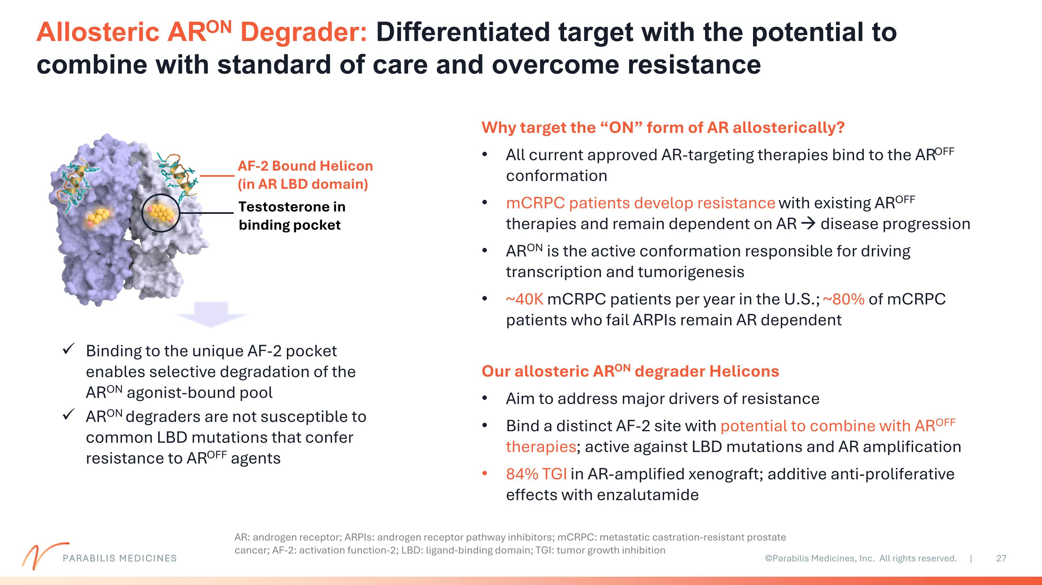
Allosteric ARON Degrader: Differentiated target with the potential to combine with standard of care and overcome resistance PARABILIS MEDICINES Why target the “ON” form of AR allosterically? All current approved AR-targeting therapies bind to the AROFF conformation mCRPC patients develop resistance with existing AROFF therapies and remain dependent on AR → disease progression ARON is the active conformation responsible for driving transcription and tumorigenesis ~40K mCRPC patients per year in the U.S.; ~80% of mCRPC patients who fail ARPIs remain AR dependent Our allosteric ARON degrader Helicons Aim to address major drivers of resistance Bind a distinct AF-2 site with potential to combine with AROFF therapies; active against LBD mutations and AR amplification 84% TGI in AR-amplified xenograft; additive anti-proliferative effects with enzalutamide Binding to the unique AF-2 pocket enables selective degradation of the ARON agonist-bound pool ARON degraders are not susceptible to common LBD mutations that confer resistance to AROFF agents Testosterone in binding pocket AF-2 Bound Helicon (in AR LBD domain) AR: androgen receptor; ARPIs: androgen receptor pathway inhibitors; mCRPC: metastatic castration-resistant prostate cancer; AF-2: activation function-2; LBD: ligand-binding domain; TGI: tumor growth inhibition

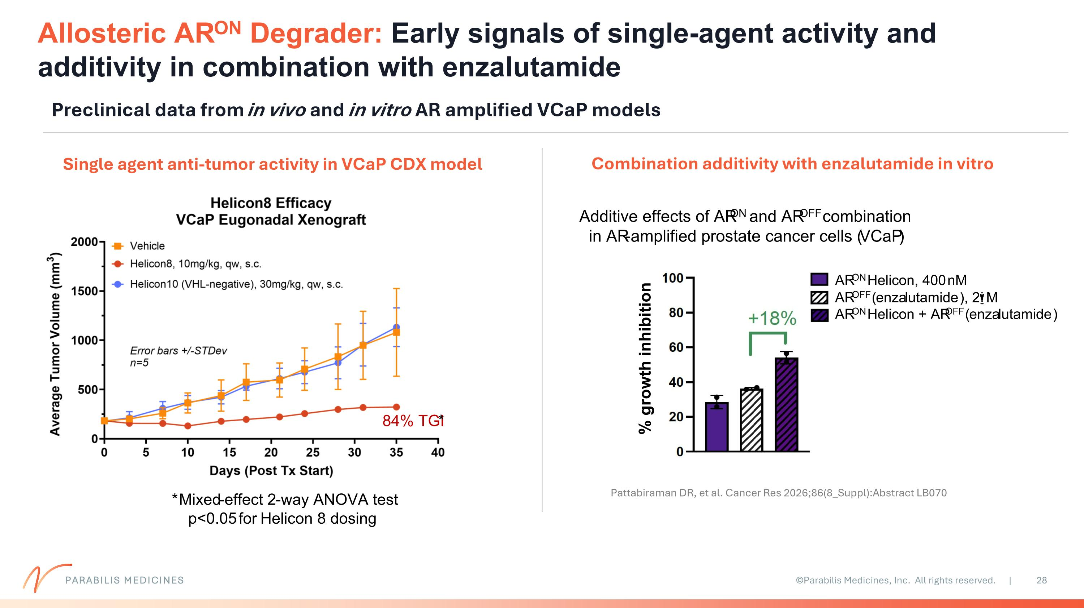
PARABILIS MEDICINES Allosteric ARON Degrader: Early signals of single-agent activity and additivity in combination with enzalutamide Preclinical data from in vivo and in vitro AR amplified VCaP models Single agent anti-tumor activity in VCaP CDX model Combination additivity with enzalutamide in vitro Pattabiraman DR, et al. Cancer Res 2026;86(8_Suppl):Abstract LB070

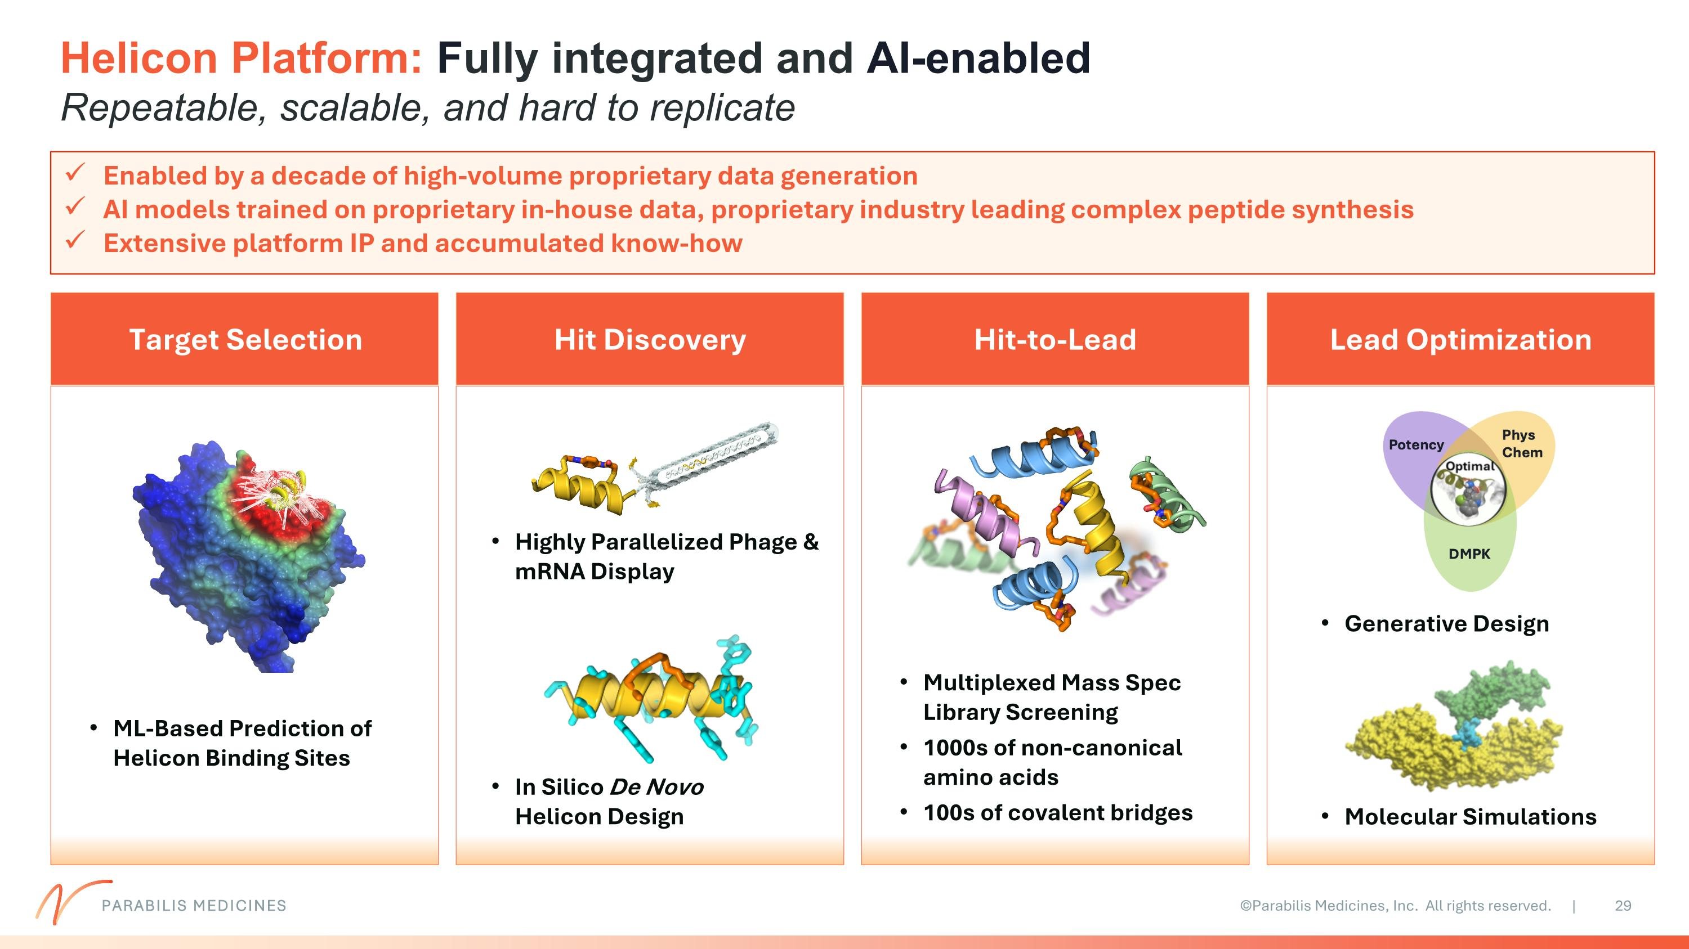
Helicon Platform: Fully integrated and AI-enabled?Repeatable, scalable, and hard to replicate Enabled by a decade of high-volume proprietary data generation AI models trained on proprietary in-house data, proprietary industry leading complex peptide synthesis Extensive platform IP and accumulated know-how Target Selection ML-Based Prediction of Helicon Binding Sites Highly Parallelized Phage & mRNA Display In Silico De Novo Helicon Design Hit Discovery Multiplexed Mass Spec Library Screening 1000s of non-canonical amino acids 100s of covalent bridges Hit-to-Lead Lead Optimization Generative Design Molecular Simulations PARABILIS MEDICINES

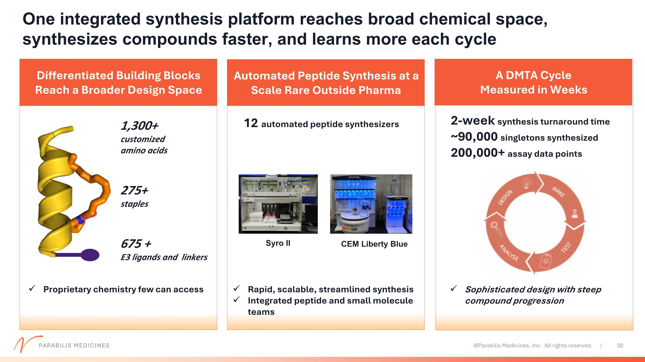
Differentiated Building Blocks Reach a Broader Design Space A DMTA Cycle Measured in Weeks Automated Peptide Synthesis at a Scale Rare Outside Pharma 12 automated peptide synthesizers CEM Liberty Blue Syro II 2-week synthesis turnaround time ~90,000 singletons synthesized ?200,000+ assay data points 1,300+ ?customized amino acids 275+ ?staples 675 + ?E3 ligands and linkers Sophisticated design with steep compound progression One integrated synthesis platform reaches broad chemical space, synthesizes compounds faster, and learns more each cycle PARABILIS MEDICINES Proprietary chemistry few can access Rapid, scalable, streamlined synthesis Integrated peptide and small molecule teams

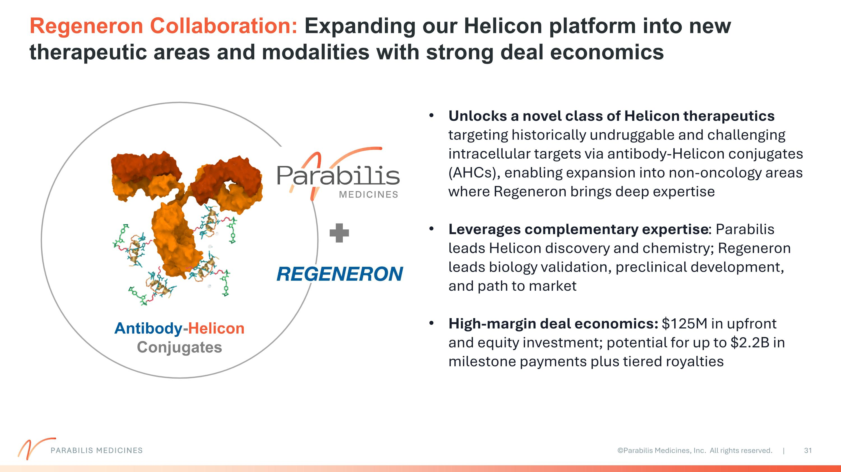
Regeneron Collaboration: Expanding our Helicon platform into new therapeutic areas and modalities with strong deal economics Antibody-Helicon Conjugates Unlocks a novel class of Helicon therapeutics targeting historically undruggable and challenging intracellular targets via antibody-Helicon conjugates (AHCs), enabling expansion into non-oncology areas where Regeneron brings deep expertise Leverages complementary expertise: Parabilis leads Helicon discovery and chemistry; Regeneron leads biology validation, preclinical development, and path to market High-margin deal economics: $125M in upfront and equity investment; potential for up to $2.2B in milestone payments plus tiered royalties PARABILIS MEDICINES

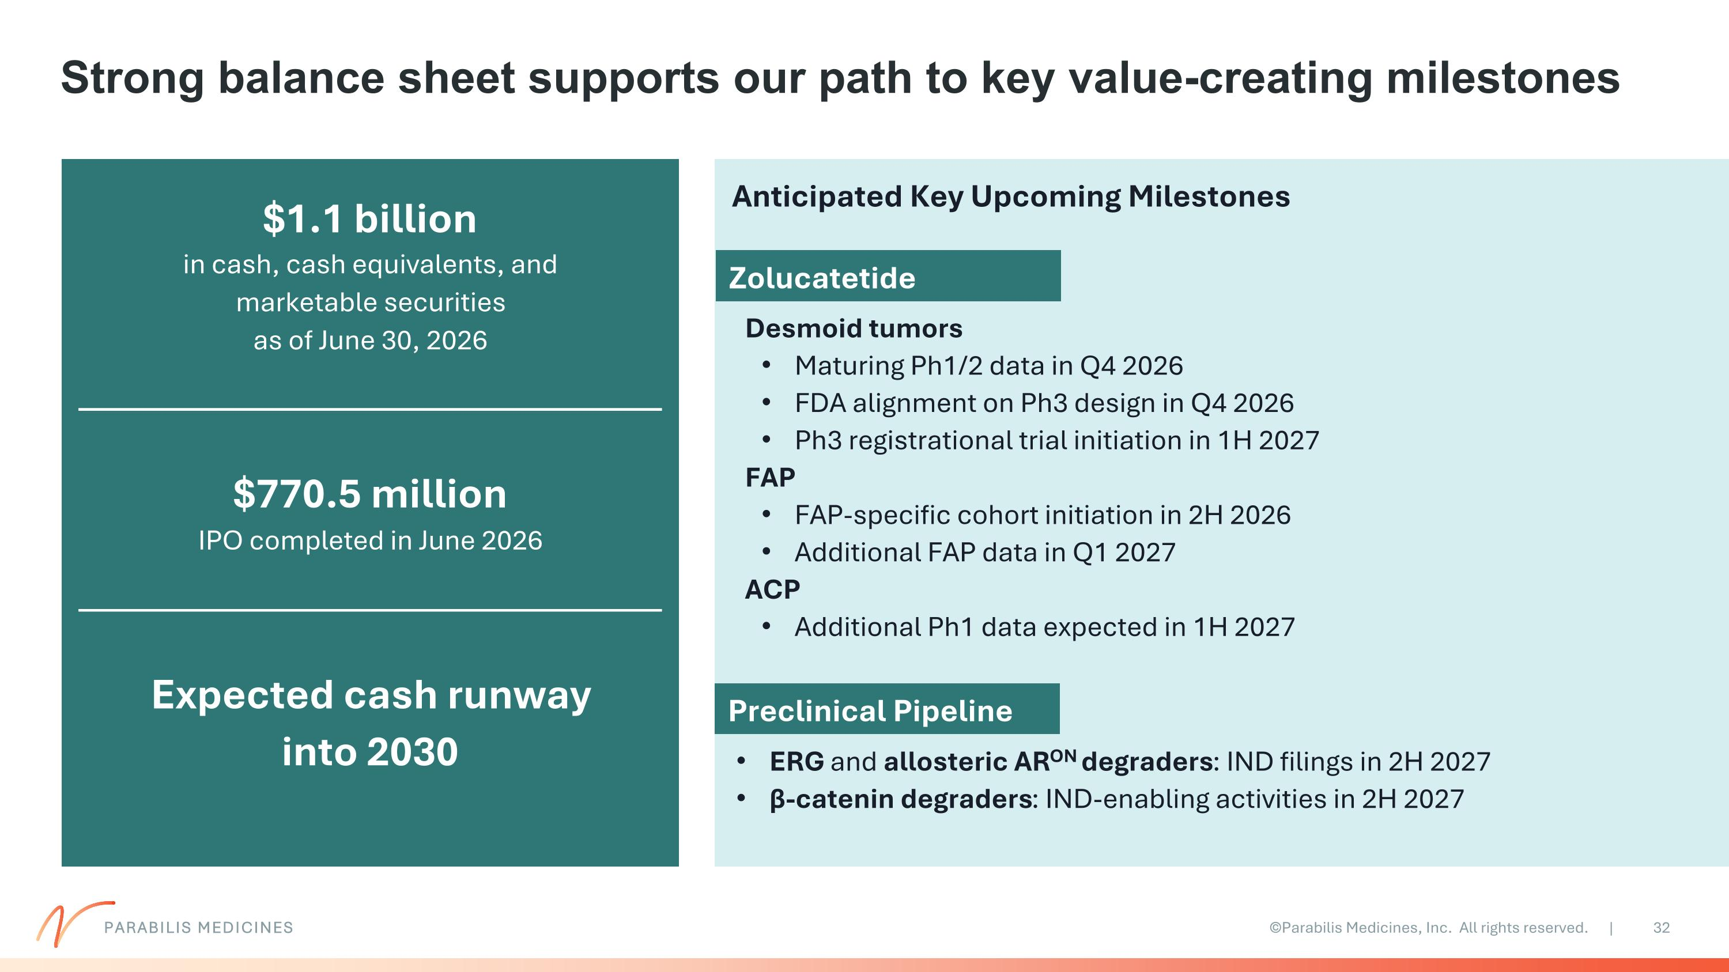
Strong balance sheet supports our path to key value-creating milestones $1.1 billion in cash, cash equivalents, and marketable securities as of June 30, 2026 $770.5 million IPO completed in June 2026 Expected cash runway into 2030 PARABILIS MEDICINES Zolucatetide Preclinical Pipeline Desmoid tumors Maturing Ph1/2 data in Q4 2026 FDA alignment on Ph3 design in Q4 2026 Ph3 registrational trial initiation in 1H 2027 FAP FAP-specific cohort initiation in 2H 2026 Additional FAP data in Q1 2027 ACP Additional Ph1 data expected in 1H 2027 Anticipated Key Upcoming Milestones ERG and allosteric ARON degraders: IND filings in 2H 2027 β-catenin degraders: IND-enabling activities in 2H 2027

